Annual Report
2018–19

Contents
Introduction 4
National Independent Safeguarding Board 5
Duties and Responsibilities 5 Annual Report Requirements 5 Membership 6
National Board’s Support and Advice to Safeguarding Boards
to ensuring they are effective 7
Other work undertaken by the National Board, or by supplementary
groups set up by the National Board, and the outcomes achieved 8
Report on the Adequacy and Effectiveness of Arrangements
to Safeguard Children and Adults in Wales 9
Recommendations to Welsh Ministers on how arrangements could be improved 26

Introduction
The 2018-2019 Annual Report of the National Independent Safeguarding Board covers a period of transition. The inaugural National Board was operational from April 2016 and
completed its term in February 2019. It produced a legacy report looking back over its three- year term in office to provide insights into how it had enacted its duties and to suggest some threads of continuity to assist their successors.
The new appointments to the National Board began work in May 2019. Therefore, there was a gap of a number of months in the functioning of the Board and whilst the public appointment process can be protracted, every effort should be made to avoid this position in the future.
As before, the new Board appointees come from diverse backgrounds and have a wealth of experience in health, social care, academia, the third sector and as a County Councillor. We are also fortunate to have a member of the last Board appointed for a second term which has been invaluable in providing continuity and insight into the more detailed workings of our predecessors.
Reporting on the adequacy and effectiveness of arrangements to safeguard children and adults in Wales during 2018-2019 has, as in previous years, focussed entirely on the work of the Regional Safeguarding Boards. In future years the National Board intends to take a broader view of what constitutes ‘arrangements’ to include all those bodies and agencies who have responsibilities and duties in relation to safeguarding. Although ambitious, this will hopefully produce a more comprehensive view of the state of safeguarding in Wales.
No one should underestimate the challenge of both protecting children, young people and adults from harm and in preventing such harm in all its forms and wherever it may occur.
It is a challenge that professionals and organisations face daily, but if safeguarding is truly ‘everybody’s business’ it is a challenge we should all face every day.

National Independent Safeguarding Board [NISB]

Duties and Responsibilities

The National Board has three primary duties set out in the Social Services & Well-being (Wales) Act 2014:
- To provide support and advice to Safeguarding Boards with a view to ensuring that they are effective
- To report on the adequacy and effectiveness of arrangements to safeguard children and adults in Wales
- To make recommendations to the Welsh Ministers as to how those arrangements could be improved (S.132 (2)).

In addition, eight specific responsibilities of the National Board are set out in Working Together to Safeguard People, the Part 7 Guidance on Safeguarding. They are that the National Board:
- works alongside Safeguarding Adults Boards and Safeguarding Children Boards to secure consistent improvements
in safeguarding policy and practice throughout Wales (para 246)
- will engage with the chairs of the Safeguarding boards, and relevant inspectorates…at least twice a year (para 258)
- will stay abreast of evidence and policy approaches to safeguarding and protection in other parts of the UK and beyond in order to learn from those and to evaluate Wales’ relative performance (para 261)
- where a theme of concern is identified… the National Board could recommend
to Welsh Ministers that the matter be escalated to Welsh Government for exploration or to the relevant inspectorate (para 263)
- will use mechanisms to regularly engage with a range of expert reference groups, practitioners and individuals (para 264)
- will publish its own annual reports including any work it is planning. It will also hold an annual engagement event or events (para 265)
- has a specific duty under section 133 (2) (d) of the Act to “consult with those who may be affected by arrangements to safeguard adults and children in Wales.” It will use that duty to enhance its understanding of and extend its experience of safeguarding and protection in Wales (para 266)
- will consider the learning from the ‘user engagement’ activities of the Safeguarding Boards (para 266).

Annual Report of the National Independent Safeguarding Board
The information that must be contained in the National Board’s Annual Report is specifically
described in The National Independent Safeguarding Board (Wales) Regulations 2015.

Membership of the National Independent Safeguarding Board

2016 – February 2019

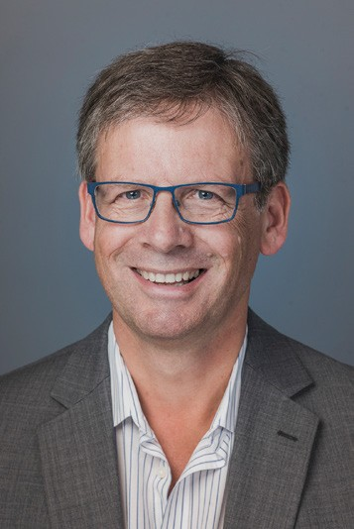

Simon Burch
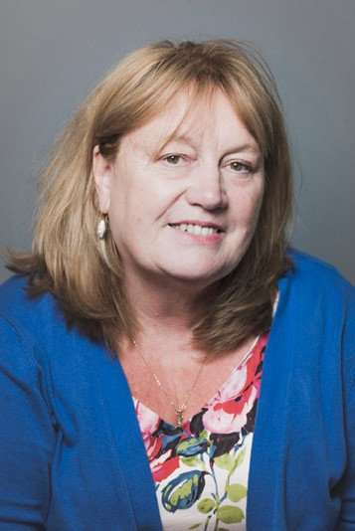
Jan Pickles
Margaret Flynn [chair]
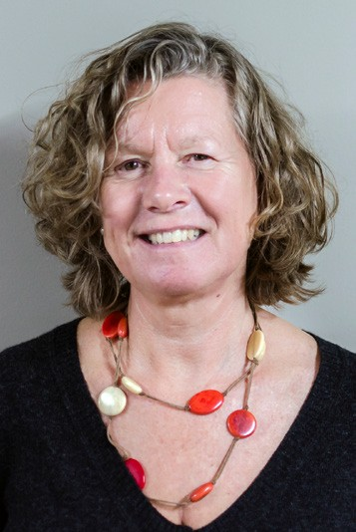
Rachel Shaw
Ruth Henke
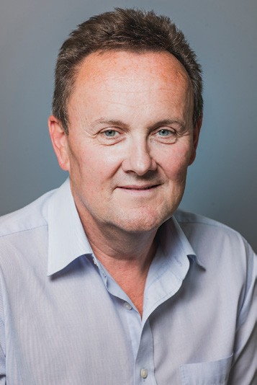
Keith Towler

May 2019 to date

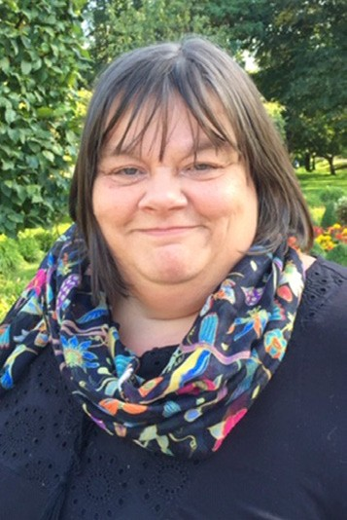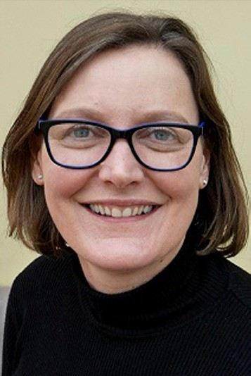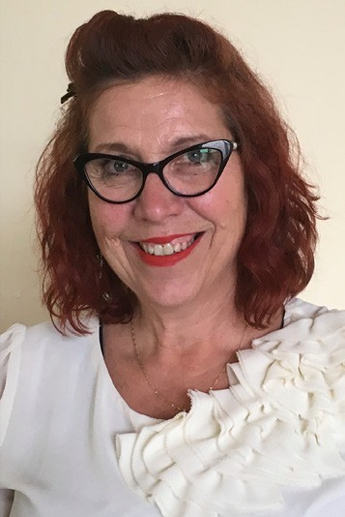

Jo Aubrey

Jan Pickles
Tessa Hodgson
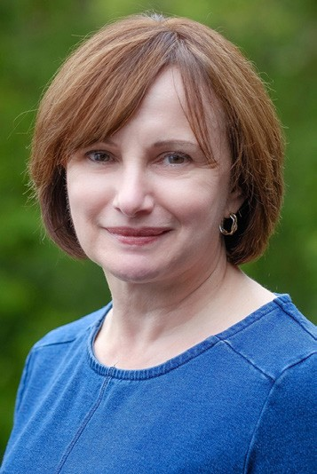
Jane Randall [chair]
Karen Minton
Tony Young

National Board’s Support and Advice to Safeguarding Boards to ensure they are effective

The previous National Board members worked alongside the Regional Boards throughout the year participating in Regional Safeguarding Board meetings and sharing their knowledge where appropriate. The contribution of individual National Board members has been welcomed by the Regional Boards and has been reflected in the feedback received.
‘…different professional expertise including strong legal view bringing fresh insight…diligent and supportive participation in regional boards.’
‘The oversight provided by having a member of the National Board on the Regional Board has been a real positive’
Where issues arose that presented particular difficulties to the Regional Boards, the NISB commissioned specific pieces of work.
One example was around Elective Home Education which will be the subject of a Welsh Government consultation during 2019.
There was a continued focus on how to manage the learning at a national level, from all of the safeguarding reviews undertaken by the individual Regional Boards. As a result, Cardiff University School of Social Science and School of Law and Politics were commissioned by the National Board to produce a thematic review of Child Practice Reviews in Wales. The National Board will publish the findings of this review in 2019
-2020.
The National Board also continued to support the work begun in previous years to find a technological solution for the management of learning from Reviews looking ahead to how Wales could manage the ever-increasing volume of reports through a “Safeguarding Intelligence” model.
During 2016, Ruth Henke QC was instrumental in ensuring that her National Board colleagues grasped the basics of the Social Services and Well-being (Wales) Act 2014. In December 2018, the publication of ‘A Practitioner’s Guide: Basic Legal Principles’ gets to the heart of the law relating to safeguarding practice in Wales. What the Guide should do is enable the practitioner
to have a basic understanding of some of the key areas of the law which may impact upon their practice. It is hoped that this will enable them to be more confident when
making difficult decisions, alert them to when they may need to look a little deeper and empower them to know when they need to ask for assistance. Above all this guide is intended to give the practitioner access to the basic legal principles upon which their daily actions and decisions should be based. The National Board disseminated the Guide via Regional Safeguarding Boards and it is available on the National Board website.

Other work undertaken by the National Board, or by supplementary groups set up by the National Board, and the outcomes achieved

National Board members contributed to a number of advisory and working groups throughout the year:
» The Welsh Government’s Secure Accommodation Task & Finish Group
» The Independent Inquiry into Child Sexual Abuse, Wales Group
» The Wales Council for Voluntary Action’s Safeguarding Group
» The Education Workforce Council
» The Positive Behaviour Support and Restrictive Practices Guidance Task and Finish Group
» Chaired the All Wales Practice Guide Task and Finish Group on the Impact of Domestic Abuse on children and Young People which finalised its guidance in January 2019.
» The Contextual Safeguarding Advisory Board, University of Bedford.
The NISB contributed to shaping the Relationships and Sexuality Education elements for the new curriculum 2022 which was accepted by the Minister in May 2018 and has been piloted in schools since then. Its intention is to equip children and young people with a key tool to keep them safe from violence, abuse and neglect. This high- quality provision has the potential to act
as one element in a holistic safeguarding curriculum delivered through a whole school approach alerting others that the onus and responsibility is not on the child to keep themselves safe.

Report on the Adequacy and Effectiveness of Arrangements to Safeguard Children and Adults in Wales

As in previous years, for 2018-2019 this is based solely on the arrangements to safeguard children and adults in Wales that are the responsibility of Regional Safeguarding Boards and is reliant on the content of the Annual Reports of the Regional Boards.
There are six regions in Wales, in 2018-2019 they were:
» Cardiff and Vale
» Cwm Taff
» Gwent
» Mid & West Wales
» North Wales
» Western Bay.

All six regions produced a single Annual Report to cover the work of the Safeguarding Children and Safeguarding Adult Boards.
Only one region has a single fully integrated children and adults board. The other five maintain discrete boards for children and adults although they work closely together and, in each region, they have support from a shared Business Unit.
All but one region produced their annual reports within the statutory timescales.
The delay was addressed with the chairs of the relevant Regional Boards by Welsh Government.
The content of the Regional Safeguarding Boards’ Annual Report is laid down in para 209 in the Social Services and Well-
Being (Wales) Act 2014 guidance ‘Working Together to Safeguarding People – Volume 1 – Introduction and Overview’.
All the regions’ annual reports contained the required content.

Membership of the Safeguarding Boards

The statutory partners of the Safeguarding Boards include the local authorities for each region, chief officers of police, the Local Health Board, NHS Trusts providing services in the area, and the providers of probation and youth offending services. In addition, boards have representation from Public Health Wales Safeguarding Team, secure settings in the region and third sector agency representatives.
All the boards in 2018-2019 were chaired by Directors of Social Services.
All the Regional Boards provided a list of the members of their Boards. One region provided this information by role only, whilst the other five included the individuals’ name as well as position held.
Three regions provided data about attendance at Board meetings for the year. However, in each of these regions there was evidence of agency representatives who failed to attend a single meeting, or who only attended one meeting, all year. There was no explanation provided or description of actions taken to address this. Further there was no assessment of the impact that this might be having on the functioning of the Board or its sub-groups.

Actions Safeguarding Boards have taken to achieve particular outcomes

All the regions identified the boards’ priorities for the year. What was less clear was what criteria had been used to determine why these were their priorities and what evidence base or learning had been used to select them.
The number of priorities for each board ranged from between two and seven priorities. However, when looking at the number of priorities across both children and adult boards this ranged from between four and eight.
Activities to achieve these priorities were described but little evidence was presented on how effective those activities had been or what improvements need to be made going forward into next year to achieve their desired outcomes.
Each board focussed on their infrastructure and governance arrangements and a number referred to the development of performance management frameworks. Again, there was little evaluation of how effective these had been and what, if any, changes were needed in the future.

The extent to which Regional Safeguarding Boards have implemented their most recent annual plans, with particulars of how far any specific proposed improvements were implemented

Each Safeguarding Board is required to publish its Annual Plan for the forthcoming year no later than the 31st March.
There was considerable variation in the Annual Reports as to how the Annual Plan was referenced. This ranged from nothing at all to reproducing it extensively. Each Board described a wealth of activity appropriate
to safeguarding that had been undertaken throughout the year and as such appeared to be making progress in implementing their plans for each priority. Only two regions attempted to describe in explicit terms how far any specific proposed improvements had been implemented.
It is worth noting that 19 of the 32 priorities identified in 2018-2019 are the same ones identified for 2017-2018. Therefore, it is important that the Regional Boards consider how they can better describe not only the activities they have undertaken in a given year, but the degree to which individual proposed improvements have been implemented, whether they are achieving the intended outcome and whether there were any particular challenges or barriers to implementation.

How Regional Safeguarding Boards have collaborated with other persons or bodies engaged in activities relating to the boards’ objectives

All the boards described how they have collaborated with other persons and bodies engaged in activities relating to safeguarding. There was evidence of a wide-ranging level of collaboration with
regional and national bodies and institutions. Some key examples included working with:
» Other Regional Boards as the Project Board overseeing the production of the Wales Safeguarding Procedures
» Community Safety Partnerships on Domestic Homicide Reviews and developing local strategies for Violence Against Women Domestic Abuse & Sexual Violence (VAWDASV)
» Working with the Home Office and Cardiff University to pilot the application of the Child Practice Reviews/Adult Practice Review methodology to Domestic Homicide Reviews
» Public Service Boards in relation to learning from safeguarding reviews
» Coroners to ensure lessons learnt
» Regional Partnership Board to source funding for advocacy development
» The All Wales Mental Capacity Act, Deprivation of Liberty Safeguards network
» The Association of Voluntary Organisations

None of the Boards made any reference to engagement or collaboration with the Older People’s Commissioner or the Children’s Commissioner for Wales. One board made reference to a report by the Older People’s Commissioner. Both commissioners have key responsibilities in protecting and promoting the rights of their specific population
groups and engage extensively with their stakeholders. They have safeguarding and stopping abuse as key priorities in their work plans, so this seems a potentially significant omission to both inform the work of the Regional Boards and to influence national safeguarding priorities.

Any requests the Regional Safeguarding Boards have made to qualifying persons under section 137(1) for specified information, and whether the requests were complied with;

No such requests were made by any of the Regional Boards in 2018-2019. This means that this power has only ever been used on two occasions since 2016.
However, one Board noted that it had been able to request information using agreed terms of reference and that these requests have always been acknowledged and the information supplied.

Achievements the Safeguarding Boards made during the year

Each region described their achievements in different ways within their annual reports. Some describing all achievements and work in progress within the narrative of the report whilst others highlighted particular achievements of note or devoted a section of their report to describe their key achievements.

Cardiff and Vale of Glamorgan Regional Safeguarding Boards

Cardiff and Vale of Glamorgan Boards described their achievements throughout the narrative of their report:
» Led the review of the All Wales Children’s and Adult’s Safeguarding Procedures
» The shared elements of the boards’ agendas have grown and developed.
» Development Day held in January 2019 ensured that each priority was assessed and any objectives that require further attention were carried forward to the 2019-20 annual plan.
» The boards worked to produce a multi- agency performance framework that would be reported to boards on a quarterly basis.
» As a result of a Child Practice Review recommendation, multi-agency training was held so that the board was assured that practitioners understand the relevance of Adverse Childhood Experiences and are aware of their long-term impact
» Female Genital Mutilation (FGM) Operational Group established focusing on a multiagency approach to tackling FGM
» Each member agency of the Regional Children’s Board provided a service user story to the Board
» National Youth Advocacy Service Cymru (NYAS) were commissioned to produce a report to highlight methods to engage children and young people positively within the board
» The work of the Board was promoted by the further development of the website
» Hosted multi-agency training presented by The Wales Extremism and Counter Terrorism Unit in March 2019.
» Held the Board’s first annual children &
young people’s conference
» Professionals Safeguarding Conference was held
» Child Practice Review/Adult Practice Review Development Day
» Five Child Practice Reviews were published
» Domiciliary and Care Home Forums established safeguarding as a standing agenda item at provider forums and board representation agreed
» Learning from relevant Care Inspectorate Wales (CIW) inspections into Domiciliary Care Homes within the region were made available to the RSAB
» Progress has been made in scoping information around advocacy services
» Training Sub Group has established a register of all current training and made this easily accessible on the RSAB website.
» Board have received regular updates at meetings regarding the action plan of the VAWDASV Strategy 2018-2023 in order to give oversight and assurance.
» Safeguarding Awards ceremony held as a way of celebrating individual and
collaborative safeguarding achievements
» Hosted two Crime Prevention and Safety Awareness Roadshows.

Cwm Taf Safeguarding Board

Cwm Taf Safeguarding Board highlighted the key achievements relating to its Strategic Objectives in their report:
» The 2018-19 Multi-Agency Safeguarding Hub audit programme
» The Board’s Quality Assurance Groups are only completing audits that meet an agreed referral criteria and to do these using standardised tools.
» County Lines training facilitated by South Wales Police.
» A Graffiti project, involving young people, was held to engage young people. The event covered racist and hate crime graffiti with a design created by local young people.
» A Health Champions Award was completed involving 6 young people. The course was sponsored by the Community Alcohol Project Service (CAPS). This is the only CAP Health Award in Wales currently and the young people will be invited to a UK wide Conference.
» Summer E-Bulletin, disseminated to all professionals working on our partner agencies.
» A Children’s Services Department in the region developed a database which records the views of parents/carers and the views of the individual child following case closure.

The Mid and West Wales Safeguarding Children and Adult Boards

Mid and West Wales Safeguarding Boards provided a dedicated section in their report to the Boards’ achievements throughout the year:
» Completion and Publication of Regional Strategies and Policies
- The Mid and West Wales Regional Threshold Document for Safeguarding Adults
- The Mid and West Wales Training Strategy
- The Mid and West Wales VAWDASV Regional Strategy and 5 year Delivery Plan
» The Development of a Full All-Age Integrated Safeguarding Agenda
» Executive Board Development Day
» Publication of Concise Adult Practice Review
» Local, Regional & National Collaboration for National Safeguarding Week
» A Regional Conference, ‘Putting Voice and Control at the Heart of Safeguarding Practice in Mid and West Wales’,
» ‘Lunch and Learn’ sessions held throughout Safeguarding Week in Powys, with an emphasis on CSE.
» Launch of online Suicide Awareness/ Prevention training in Pembrokeshire.

» Safeguarding session for young people in Pembrokeshire with additional needs, held by the Junior Safeguardians in association with Young Choices for Youth Forum.
» Team building event between Pembrokeshire Safeguardians and decision makers.
» Children in Need project held to raise awareness of the dangers of ‘grooming’.
» Intergenerational lunch held preceding a number of centre-based awareness raising sessions across Ceredigion.
» Dissemination of information on criminal exploitation across Powys’ Intranet and social media.
» Series of advice sessions held across Ceredigion relating to financial exploitation, in acknowledgement of the simultaneous ‘Let’s Talk Money’ week.
» Range of events held across hospitals in the region, providing visitors with a variety of information on pertinent safeguarding topics.
» Delivery of CSE lessons throughout local schools by Dyfed Powys Police.
» Outreach work in care homes, leisure and sport facilities and a variety of other centres and individuals raising awareness
and offering guidance in relation to a wide variety of safeguarding issues.

Gwent Safeguarding Boards

Gwent Safeguarding Boards included a dedicated section in their annual report to set out 17 key achievements or ‘good news’ stories which the Boards felt demonstrated the breadth of its work over the past year:
- Embedding the new Boards sub-group structure has demonstrated a more dynamic and streamlined framework with less duplication.
- Finalised the content for the newly- developed Gwent Safeguarding website
- A Board Development Day for SEWSCB and GwASB Board members was held in autumn 2018.
- During National Safeguarding week, the region developed and disseminated a suite of multi-agency practitioner information relating to the nationally agreed theme
of exploitation. They also collaboratively worked with police, third sector colleagues and other partners to deliver a series
of multi-agency local events to raise awareness in relation to Adverse Childhood Experiences, County Lines and VAWDASV survivor case studies.
- Worked with partners to produce the Boards strategic plan, and in turn this ensured involvement in the production of the Gwent area plan and VAWDASV regional strategy.
- Disseminated the learning from one completed child practice review.
- Made more effective and greater use of Multi Agency Professional Forums, where learning for practitioner groups is identified, having tested a variety of different methods.
- Introduction 7 minute briefings, to be completed by the reviewers of Child or Adult Practice Reviews, as an integral tool to effectively disseminate learning and prompt reflection.
- A Local Authority within the Board region
was one of the first in Wales to make
a successful application for an Adult
Protection Support Order (APSO,) This provided us with experience to share and it enabled us to identify the need to develop specific regional guidance to support professionals when applying for and executing future APSOs.
- Completed a pilot project to streamline the Domestic Homicide Review process across Gwent.
- Local Safeguarding Network meetings and six monthly practitioner forum events
- Embedding of Hot Topics at both Board and Local Network level has enabled members to raise safeguarding concerns at a variety of levels.
- Continued to work on an ambitious project to develop a joint Quality Assurance Framework which covers the work of both Boards. A pilot to test the information and data collection process was completed
in advance of consulting with Board members. They have now commissioned a comparison study to test the intended methodology.
- Continued to deliver core business for both Boards’ including undertaking reviews, delivering the Board approved training packages, reviewing and revising
regional protocols and procedures, taking a coordinated, active role in the consultation of the newly developed national safeguarding procedures, working with our colleagues across Wales, and being advised by front line practitioners, service users and families.
- At the end of 2018/2019, an inaugural joint Board meeting was held where items relating to both SEWSCB and GwASB were considered along with joint key messages for members of both Boards.
- Promote the use of MASE meetings as a good multi agency response to all of the actions specified in their strategic plan. From autumn 2018, these meetings are now facilitated across the whole region.
- Delivery of a high-quality, multi-agency training programme coordinated by the Boards’ Delivery Group.

North Wales Safeguarding Board

North Wales included a dedicated section in their annual report about the achievements of the Board during the previous year:
» The NWSAB were highly commended for their work around self- neglect at the Social Care Wales Accolades in the category of “Effective Approaches to Safeguarding Practice”,
» Development of Self-Neglect Leaflets for
the General Public and Professionals.
» Regional Conference on Self-Neglect.
Presentation given by Professor Michael Preston Shoot
» Launched the “Herbert Protocol” in partnership with North Wales Police. An initiative which encourages carers/ residential care staff to compile useful information which could be used in the event of a vulnerable person going missing.
» Established the Continuity of Practice events in partnership with the CSE Regional Adviser

» At the Board’s Business Development Day completed the self-assessment toolkit developed by Practice Solutions.
» The Board Business Unit, in collaboration with Local Delivery Groups, co-ordinated and supported a regional programme of events to support National Safeguarding Week
» The Business Co-ordinator developed a series of “Fact Sheets” on the different forms of exploitation.
» The NWSB conference during Safeguarding Week included presentations on: County Lines · Modern Slavery · Child Sexual Abuse · Forced Marriage
» The Board also received a powerful presentation from a victim of coercive control and domestic violence.
» NWSB launched its safeguarding video See Something / Say Something

Western Bay Safeguarding Boards

Western Bay described their achievements throughout the narrative of their report and in the ‘Status at March’ column of their Annual Plan:
» Links made with the human trafficking forum who provide data six monthly to board
» Training delivered to first responders on National Referral Mechanism (Modern Slavery)
» Responded to consultation on the Welsh government guidance on safeguarding children at risk of CSE
» Links with CIW to provide data around complaints in Care Homes
» An overarching exploitation policy is being developed for encompassing children and adults
» All child and adult sub groups have come together, thus allowing cross fertilisation of ideas
» There has been a focus on training with the development of an interactive training package including county lines, CSE, harmful sexual behaviour, human trafficking, modern slavery, and radicalisation and hate crime for both adults and children.
» Training of trainers is being established to create a pool of people who can deliver this training across Western Bay.

Extent to which each member of the RSB contributed to the Boards’ effectiveness

All the regions recorded attendance at meetings by members as evidence of their contribution to the board. Three regions included accounts from partner agencies on their specific contributions including in some examples, the priorities of the individual agency and how they link specifically to the priorities of the board.
There were however, obvious inconsistencies in that not all partners of the board provided this information and with no explanation
of why this was the case. Some national organisations also appeared to contribute reports in some regions and not in others.
There was little evidence or assessment presented about how these contributions had impacted on the board’s effectiveness.
There was also little evidence to show how the boards were holding individual agencies to account for their safeguarding duties and responsibilities. Some boards
have introduced ‘hot topics’ items into their meetings to allow partners to share issues of particular concern and one region reported that agency inspection reports were shared at board meetings. They did not describe the findings, good or bad, of these inspections, nor did they comment on whether they had been assured by the findings or satisfied with any improvement actions proposed.

An assessment of how the Safeguarding Board used its resources in exercising its functions and achieving its outcomes

Most boards acknowledged that resources used to support the work of the Regional Safeguarding Boards were not confined or restricted to financial contributions from statutory partner agencies. Further that members provided a significant amount of their time to support the boards and their work. This was often in addition to their identified professional roles and day to day responsibilities. The variable and diverse nature of the Boards’ work made this difficult to quantify and was not always obviously visible to other professionals and agencies. Some examples given were the management and publication of Child and Adult Practice Reviews, the development of regional protocols and policies, as well as projects that required high levels of professional input, knowledge and expertise.
All boards used the national funding formula to assess and identify annual financial contributions from statutory partner agencies. Only one region published the monetary contributions of the statutory partners as well as the percentage of the
total. It is therefore not possible to assess the contribution of organisations on a national basis. It is also unclear whether regions have underspends and if there are surpluses that are carried over year on year. In the interests of public transparency, the Regional Boards should consider publishing their financial accounts as part of their Annual Reports.

The total expenditures ranged from
£125,065 to £355,055 giving a national total expenditure of £1,309,117. The largest proportion of expenditure in all regions was
for the Business Units with costs ranging from
£81,166 to £288,655.
There were some other interesting variations in expenditure. For example, one region was spending over £1000 in indemnity insurances which no other board noted. Three regions specified the costs of undertaking child and adult practice reviews and this expenditure varied from £2890 - £48,246 for the year but it is unclear how many reviews this covered in each case.
While the facts of the income and expenditure were stated, the reports lacked narrative around the rationale for both the income requested from agencies and how expenditure was determined in relation to achieving the boards’ outcomes. This would have been particularly interesting for those board whose income was less in 2018-2019 than in 2017-2018.

Any underlying themes in the way the Safeguarding Board exercised its functions, as shown by an analysis of
cases it has dealt with, and any changes it has put into practice as a result

This includes lessons learnt from child practice reviews and adult practice reviews carried out by Safeguarding Boards and from other reviews and investigations.
Not all boards described specific themes in their reports although they reported that the work had been done and themes had
been identified and discussed at board. The following are the themes identified within the reports:

Learning from Child Practice Reviews

» Training and awareness raising for health staff on learning disabilities and learning difficulties, and their effect on parenting
» Better systems to improve the communication between GPs, Midwives and Health Visitors
» Development and implementation of a Regional Protocol for Injuries in Non- Mobile Babies
» Development of a Regional Risky Behaviour Policy
» Awareness raising of Absenteeism Procedures in Schools for year 11 pupils.

Learning from Adult Practice Reviews

» Development of multi-agency transition principles
» Significance of Quality of Care for adults leading to Board drilling down into residential and domiciliary care for adults
» Guidance required around the process of emergency admissions and the assessment of risk
» Pressure Sore, Dementia and Record Keeping Training for Care Home Managers
» Working with challenging families - development of multi-agency guidance & training on conflict management techniques for frontline staff.
» Oversight of Direct Payments – 7 minute briefing developed around Direct Payments and safeguarding available on Board’s website.

Learning from other Reviews or Investigations

» Radicalisation of Young Person – led to commissioning a Child Practice Review which is to be completed.
» Importance of Contextual Safeguarding as a frame of reference, especially in relation to County Lines and Child Sexual Exploitation.
» Rising evidence that family resilience is being increasingly challenged and that this is contributing to the susceptibility of children to the effects of Adverse Childhood Experiences.
» Young people are identifying mental health as a prime concern with attendant safeguarding risks.
» Multi-agency Practitioner Fora identified issues around compliance with Pre-birth assessment processes and inter-agency working at case conference. This led to formal audit of these areas of practice.
» Impact of CSE and exploitation leading to production of overarching policy and an interactive training package.
» The incidence of ‘falls’ amongst adults appears to be more prevalent as an issue and priority will be given to this is current year’s business.
» Repeat notifications from the police to social care relating to mental health and substance misuse
» Independent review undertaken into a care home closure led to an update of the regional escalating concerns policy
» Identification of gaps in identification by
those care homes in escalating concerns
– no clear plan identified in the report on
how this was to be addressed.

All Boards provided data relating to their safeguarding activity but there was little or no analysis of what this meant, how this provided assurance to Boards about the
quality of their safeguarding arrangements or how they intended to use it to inform any improvement plans.

When and how children and adults exercised an opportunity to participate in the safeguarding Board’s work and how this contributed to the Board achieving its outcomes

In its previous Annual Report, the NISB commented on the hesitancy noted in most regions’ accounts of participation, with a focus on the preparatory actions required to engage with stakeholders. This year there is still a wide variation in the boards’ approaches to participation but all but one
region engaged directly with stakeholders. In one region there were lots of good examples of engagement and participation work undertaken by agency representatives within their own organisations but no examples of participation work undertaken on behalf of the board.

Examples of Engagement with Children and Young People

» National Youth Advisory Service Cymru commissioned to report on methods to positively engage children & young
people with the board, its decisions and workstreams.
» Pilot project to develop feedback from children & young people’s involvement in the child protection process
» Children & Young People’s annual conference attended by pupils from secondary schools in the region and with schools’ Child Sexual Exploitation Ambassadors presenting.
» Two boards have Junior/Children’s Safeguarding Boards and reported on their activity and how their views had been sought.
“it was nice to have an intelligent conversation about actual issues affecting young people in Wales” (from a young person attending the executive board).
» Board members attending Youth Forums
» Engagement with families involved Child Practice Reviews

Examples of Engagement with Adults

» Participation in Citizen Panels
» Engagement with Domestic Abuse survivors
» Engagement with families involved in Adult Practice Reviews

The number of Adult Protection & Support Orders which were applied for in the Safeguarding board area, how many were made, and how effective they were.

Adult Protection and Support Orders enable an authorised officer, and any other person specified in the order, to enter ‘premises’ to speak to an adult suspected of being at risk of abuse or neglect in private, to establish whether or not they can make decisions freely, to assess whether the person is an adult at risk and establish what, if any action should be taken. The statutory guidance defines ‘premises’ as including domestic premises, a residential care home, a nursing home, a hospital or any other building, structure, mobile home or caravan in which the person is living.
In two Regions a Local Authority applied for a single Adult Protection and Support Order (APSO) in 2018-2019. In one region
the case was in respect of an individual with a diagnosed mental health disorder. Concerns were identified in respect of their wellbeing both emotionally and physically and the potential controlling influence of their partner.
The partner was preventing services from being able to provide support to the individual. Due to the interference of the partner after attempts had been made to undertake a Mental Health Assessment, a decision was made by the authorised local authority officer to apply for the APSO so that agencies could meet the individual without the partner being present.
In the second region it was noted that a Local Authority successfully applied for the Order. Although there was no comment on the effectiveness of the Order, the Board states that they are using this experience to inform and enhance its regional process.

Any information or learning the Safeguarding Board has disseminated, or training it has recommended or provided

During 2018-2019 the Regional Boards have been working with Social Care Wales to develop a Regional Safeguarding Board Training Framework. All regions have a training group that oversees their training priorities and the delivery of training in their area. Two boards specifically mentioned using their website to disseminate information and to share details about training that is available.
One board produces an e-bulletin and included links to work undertaken elsewhere
e.g. You Tube link to children accused of witchcraft, and linked to another Regional Board’s protocol around hoarding.
Two boards produced DVDs or interactive training around Domestic Abuse and Exploitation and one board had developed standards for its safeguarding trainers.
All boards described extensive training arrangements provided both by partner agencies and the boards themselves. In addition to training around safeguarding processes a wide variety of topics were covered including:
» Learning from Adult Practice and Child Practice Reviews
» Radicalisation
» County Lines
» Adverse Childhood Experiences
» Domestic Abuse and learning from Domestic Homicide Reviews
» Self-Neglect
» Human Exploitation
» Child Sexual Abuse
» Sexual Exploitation

A number of these topics reflect the theme of Safeguarding Week in November 2018 which was exploitation. Two regions held professional conferences in that week with speakers covering these issues.

How Safeguarding Board has implemented any guidance or advice given by the Welsh Ministers or by the National Board

The Regional Boards reported that they implement guidance and advice given by both Welsh Government or by the National Board without going into specific details.
Active contribution to national work is highlighted e.g. the development of the national safeguarding procedures and one region described on-going dialogue around national issues giving examples of forensic health services for victims of sexual assault, stronger legislation around children who are home educated, and DBS checking of existing employees.
Two reports produced by the National Independent Safeguarding Board were noted as helpful:
» Thematic Analysis of Reviews into Adult Deaths in Wales 2018
» A Practitioner’s Guide: Basic Legal Principles’ 2018

Other matters relevant to the work of the Safeguarding Board

Regions reported matters that were of particular note to them, for example, two regions highlighted the impact of
organisational reorganisation and one region highlighted the impact of austerity on the partner agencies that make up the board.
However, there was one recurring theme across most of the boards which related to data.
Issues were highlighted either around lack of data or problems with data collection. Three boards were either developing or about to implement quality assurance or performance management frameworks.
There is no indication that there has been any collaboration between boards in this work or that a national position has been sought.

Additional Matters to Report

In addition to the safeguarding arrangements described in the Regional Board’s Annual Reports the National Independent Safeguarding Board is also required to highlight examples where learning information and resources have been shared between Safeguarding Boards within a Safeguarding Board area or between Safeguarding Boards across Wales.

All Wales Procedures Project Board

Cardiff and the Vale Safeguarding Board has been leading on the development of the new Wales Safeguarding Procedures for children and adults and the Regional Boards have been actively involved in the Project Board overseeing the development of the procedures. Individual representatives from Regional Boards have also been involved in editorial groups to review specific chapters and in the development and consultation in respect of the Practice Guides for Children with Welsh Government.

Shared Learning

All Regional Safeguarding Board Managers met regularly to share good practice, discuss areas of development and identify emerging national safeguarding trends. They also collaborated to plan National Safeguarding Week, developing regional themes and sharing good practice.
Child and Adult Practice Reviews were regularly shared to ensure learning was disseminated across the regions.
Cwm Taf Safeguarding Board agreed a collaborative approach to completing a Domestic Homicide Review with Gwent Safeguarding Board. This involves piloting the completion of the Domestic Homicide Review using the Adult Practice Review approach. This work will be completed
in 2019/20.
In September 2018 Mid & West Wales Regional Board Manager and Regional Training Sub–Group Chair attended and participated in a workshop held by the North Wales Regional Safeguarding Board to support the development of a North Wales Training Strategy.
Regional Safeguarding Boards have introduced “7 Minute Briefings” to support widest dissemination of case review learning which have been shared with other Boards.
Boards also evidenced alignment to the work of Public Service Boards e.g. Gwent in relation to the learning from DHRs, APRs and CPRs and the funding of Advocacy development.
Establishment Local Safeguarding Network Practitioner Forum which has provided awareness events concerning ACEs, County Lines and the relationship to the VAWDASV agenda

Shared Resources

All Regions produced a single Annual Report covering the work of both their Adults and Children’s Boards. They also all have shared jointly funded business management arrangements.
All Boards are working on joint governance arrangements between
their adult and children’s’ boards which is reflected in their subgroup structures and multiple examples of joint children and adult groups. In some regions they have also included the VAWDASV agenda to improve coordination of learning, focus and effort.
The Business Managers are currently working on ensuring there is consistency across the Regional Safeguarding Boards in terms of format of all published documents (e.g. Annual Plans, Annual Reports and Policies and Procedures)

Recommendations to Welsh Ministers on how safeguarding arrangements could be improved

Safeguarding Adults at Risk

From our analysis of the Regional Boards Annual Reports it is apparent that the arrangements for safeguarding adults at risk is still less developed than the arrangements for safeguarding children. It is also evident that there is not sufficient data or information about abuse of older people in Wales. A view supported by the work of the Older People’s Commissioner for Wales and highlighted
in her State of the Nation (October 2019) Report.

Recommendation 1
Welsh Government should ensure that the Technical Guidance of the Social Care Performance Framework includes information about the abuse of older people by collecting data broken down by age group.

From Activity to Performance

All Boards provided data relating to their safeguarding activity but there was little or no analysis of what this meant, how this provided assurance to Boards about the
quality of their safeguarding arrangements or how they intended to use it to inform any improvement plans. Issues were highlighted around lack of data or problems with data collection.
Three boards were either developing or about to implement quality assurance or performance management frameworks. There is no indication that there has been any collaboration between boards in this work or that a national position has been sought.
Last year the NISB recommended to Ministers that “the Regional Boards, the National Board and Welsh Government identify and agree five measures which reveal something of the adequacy and effectiveness of safeguarding arrangements”. This work has not been undertaken as yet.

Recommendation 2
Welsh Government should work with Regional Safeguarding Boards, the NISB and other
key stakeholders to develop a Performance Framework for Safeguarding in Wales.

Learning from Safeguarding Reviews
Recommendation 3
Welsh Government should as part of this review, consider how the national repository and machine learning can be embedded into mainstream review processes
and finance secured to make it sustainable as a resource for the long term.

A considerable amount of both time and resources is invested each year in
undertaking safeguarding reviews in Wales. Despite this there is not clear evidence of learning between Regions in such a key area
of responsibility.

The National Board has supported, including financially, three discrete pieces of work with Cardiff University around reviews to date:
» A thematic analysis of reviews into adult deaths in Wales
Recommendation 4
Welsh Government should commission a thematic analysis of all safeguarding reviews on a bi-annual basis to identify themes and share learning on a national basis.
» A thematic analysis of Child Practice Reviews in Wales
» The Safeguarding Intelligence Project
– the creation of a national repository for safeguarding reviews and the development of machine learning as a
tool for identifying common themes from multiple reviews across Wales, enabling thematic analysis and promoting shared learning nationally.
» Starting in December 2019, Welsh Government is undertaking a piece of work to look at the safeguarding review processes in Wales.

Keep in touch
www.safeguardingboard.wales @NISBwales
safeguardingwales

