National Independent Safeguarding Board Wales

Bwrdd Diogelu Annibynnol Cenedlaethol Cymru
Ariennir gan Lywodraeth Cymru
Fun ded by
Welsh Government

Annual Report
2017–18

Introduction

2 National Independent Safeguarding Board Wales

Intr
oduction

Annual Report 2017-18 3

Contents

Introduction | 5
1. Reporting on the Adequacy and Effectiveness of Arrangements to Safeguard Children and Adults in Wales  Membership of the Safeguarding Boards  Actions the Boards have taken to achieve particular outcomes  The extent to which the Safeguarding Boards have implemented their most  recent annual plan with particulars of how far any specific proposed improvements  were implemented  So what happened?  How the Safeguarding Boards have collaborated in activities relating to their objectives  Requests the Regional Safeguarding Boards have made under S.137(1)  for specified information  Achievements the Safeguarding Boards made during the year  The extent to which Safeguarding Board members contributed to the Boards’ effectiveness  An assessment of how the Safeguarding Boards used their resources in exercising its functions or achieving its outcomes  Underlying themes in the way the Safeguarding Boards exercised their functions as shown by an analysis of cases dealt with and any changes it  has put into practice  When and how children or adults exercised an opportunity to participate in the Boards’ work and how this contributed to the Boards achieving their outcomes  The number of Adult Protection and Support Orders (APSO) which were applied for in the Safeguarding Boards’ areas and how effective they were  Any information or learning the Safeguarding Boards have disseminated or training they have recommended or provided  How the Safeguarding Boards have implemented any guidance or advice given by the Welsh Government or the National Board  Other matters relevant to the work of the Safeguarding Boards | 6  6  8  10  12  19  22  23  30  34  36  39  43  44  47  48
2. The National Board’s support and advice to Safeguarding Boards with a view to ensuring that they are effective | 51
3. Making recommendations to the Welsh Ministers as to how these arrangements could be improved | 56

4 National Independent Safeguarding Board Wales

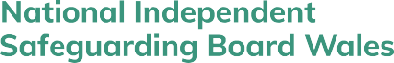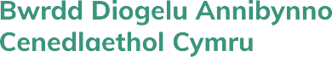
Introduction

Annual Report 2017-18 5

Dear Reader,

This is a different kind of annual report because it begins and ends with letters. This report marks the end of the first National Board’s term of office. It is our third annual report. A belief expressed in our first report is unchanged:

The National Board recognises that the requirement to prevent harm is one of the most difficult of all human activities.

The harms that children, young people and adults suffer challenge us on many levels because abuse in its many forms may happen anywhere, in our homes - where we should be most safe - and even in services that are regularly inspected. Family homes may struggle to prioritise essential care and nurturing when their strengths are overshadowed by difficulties, when members come and go and where there are lethal combinations of violence, addictions and restrictions for example. Both retrospective and prospective studies of mental health outcomes attest to the risks inherent in the neglect and abuse of children, young people and adults with different kinds of support needs.

The “people approach” of the Social Services and Well-being (Wales) Act 2014 (the SSWB Act), under which social care is integrated over the life course, is a significant means of dealing with such challenges.

In Wales, harm, which incorporates unintentional actions and acts of omission is “everyone’s responsibility.” This means that all professionals and organisations must do everything they can to ensure that children and adults at risk of abuse are protected from harm.

All Regional Boards are attuned to the importance of people receiving services in well-ordered settings, where unsuitable staff have been screened out and induction, supervision and training are prioritised.
They are attuned also to the importance of responding competently to “alerts” - the signs which are suggestive of harm – and making enquiries and taking action to support and protect individuals.

Reporting on the adequacy and effectiveness of arrangements to safeguard children and adults in Wales during 2017-18 requires the National Board to be familiar with Regional Boards’ plans and annual reports. The following section confirms progress since last year and evidences a greater confidence of the Regional Board Chairs to influence practice regionally as well as nationally and an acknowledgement of their own need to work together. We welcome the introduction of meetings between the Chairs and the Welsh Government. We believe that the Chairs taking ownership of their own meetings, unmediated by either the National Board or the Welsh Government, is a positive means of shaping the safeguarding agenda. This is aided by the renewed focus of the Association of the Directors of Social Services’ safeguarding group.

Our closing letter is addressed to the Minister. It contains recommendations which arise from our work
across Wales.

Yours sincerely,

Margaret Flynn, Keith Towler, Simon Burch, Ruth Henke, Jan Pickles and Rachel Shaw

Reporting on the Adequacy and Effectiveness of Arrangements to Safeguard Children and Adults in Wales

6 National Independent Safeguarding Board Wales

Reporting on the Adequacy and Effectiveness of Arrangements to Safeguard Children and Adults in Wales
1

Membership of the Safeguarding Boards
All Safeguarding Boards are configured on a regional basis and include the local authorities for each area, chief officers of police, the Local Health Board, NHS trusts providing services in the area, the providers of probation and youth offending services. Although there is a slight change in the
numbers of attendees, the similarity of organisations across children’s and adults’ boards is constant. The variations mostly hinge on whether or not there are secure settings in the region and the extent of third sector representation.

During 2017-18, Directors of Social Services were responsible for chairing all Regional Boards. Their co-Chairs/ Vice Chairs were drawn from Directors and Assistant Directors of Social Services, the police and Health Boards.

Medical doctors attend five out of the six Children’s Boards: designated doctors from Public Health Wales attend Cardiff and Vale and Gwent; Mid and West Wales and North Wales Children’s Boards are attended by Named Doctors from Powys Teaching Health Board and Betsi Cadwaladr UHB respectively and Western Bay by an Assistant Medical Director, Primary Care. There is no medical practitioner representation at any adults’ boards.

The Regional Boards are large. Both of Gwent’s boards have grown by a third, and North Wales’ have reduced by a third.

The number of Regional Board meetings (re either children or adults) per year varies between four,
e.g. Cardiff and Vale and six, North Wales.

The attendance of members is cited by all Regional Boards. Cardiff and Vale report on attendance at both Boards. Cwm Taf’s includes a comprehensive table reflecting attendance at the board operational committee, subgroups and whether or not agencies contributed to Practice Reviews. Gwent refers to “consistent participation.” Mid and West Wales noted that the limited availability of two partners impacted on the partnerships. North Wales presents tables of attendance for the children’s and adults’ boards and acknowledges that improvements are required in relation to
its Local Delivery Groups and practice reviewing processes. Western Bay notes that “members agree to attend 75% of Board meetings” and that 100% attendance is achieved by substituting representation.

Reporting on the Adequacy and Effectiveness of Arrangements to Safeguard Children and Adults in Wales

Annual Report 2017-18 7

Cardiff and Vale | During 2016-17, there were 36 members of the children’s Board and 24 members of the Adults Board from Cardiff and Vale of Glamorgan; during 2017-18, the same organisations were represented at the children’s board and there were 26 attendees at the adults’ board. The latter had secured representation from the Community Rehabilitation Company and HMP Cardiff. South Wales Fire and Rescue is no longer represented
Cwm Taf | During 2016-17, there were 27 members of the joint Regional Board from Merthyr Tydfil and Rhondda Cynon Taf; during 2017-18, there were 24 with no changes in the organisations represented
Gwent | During 2016-17, there were 24 members of the children’s Board and 23 members of the Adults Board from Blaenau Gwent, Caerphilly, Monmouthshire, Newport and Torfaen; during 2017-18, there were 32 members of the children’s board and 31 attendees at the adults’ board
Mid and  West Wales | During 2016-17, there were 23 members of the children’s Board and 20 members of the Adults’ Board from Carmarthenshire, Ceredigion, Pembrokeshire and Powys; during 2017-18, there were 23 attendees at the children’s board and 20 attendees at the adults’ board
North Wales | During 2016-17, there were 24 members of the children’s Board and 25 members of the Adults Board from Conwy, Denbighshire, Flintshire, Gwynedd, Isle of Anglesey and Wrexham; during 2017-18, there were 16 members of the children’s board and 17 members of the adults’ board.
Western  Bay | During 2016-17, there were 27 members of the children’s Board and 26 members of the Adults Board from Bridgend, Swansea and Neath Port Talbot; during 2017- 18, there were 24 attendees at the children’s board with membership shifting to include Hillside Secure Unit and the Young Offenders Unit at HMP Parc; and 22 at the adults’ board with HMP Swansea no longer represented

DID YOU KNOW?
During 2017-18 the Welsh Ambulance Service Trust was represented at ten of the 11 Regional Boards by the same person…

Reporting on the Adequacy and Effectiveness of Arrangements to Safeguard Children and Adults in Wales

8 National Independent Safeguarding Board Wales

Actions the Boards have taken to achieve particular outcomes
It would be difficult to comment on the adequacy and effectiveness of safeguarding arrangements without knowing the clear goals of each Board. The expectation that Regional Boards will set out the specifics of what they are willing to be held accountable to achieve is demonstrated in the following table. The emphasis is on activity and some activities are closer to positively intervening in the lives of children and adults at risk than others. There is a very strong focus on the functioning of the Boards and the Business Units.

 | Actions and Outcomes
Cardiff and  Vale | Not completed
Cwm Taf | Enhanced collaboration across children and adults safeguarding; coordinated and monitored the activities of each partner via the work plan and reviews; created a performance management framework for the sub groups; and increased the capacity of the Business Unit to support the Multi Agency Safeguarding Hub (MASH) and the coordination of reviews
Gwent | Combined workstreams across children and adults Boards to ensure good communication; connected work plans with the annual strategic plan; involved practitioners in the work of the Boards; developed a Quality Assurance framework to provide a “snapshot” of safeguarding; developed, delivered and commissioned a training programme to raise awareness of safeguarding; piloted a hybrid Domestic Homicide Review process to ensure their relevance; sought the views of people across ages on a number of topics; worked with the Regional Partnership Board to promote advocacy in adult services; and been involved in the production of the regional strategy document: Violence Against Women, Domestic Abuse and Sexual Violence (VAWDASV)
Mid and West Wales | Combined governance structures and a cross-cutting agenda for the executive boards to strengthen the strategic relationship between the children and adults boards; implemented a regional quality assurance and performance reporting framework “to better understand safeguarding practice;” developed a framework for undertaking Multi-Agency Professional Forums to ensure consistency, support reflective learning and share good practice; and embedded and strengthened the governance of VAWDASV

Reporting on the Adequacy and Effectiveness of Arrangements to Safeguard Children and Adults in Wales

Annual Report 2017-18 9

 | Actions and Outcomes
North Wales | Ensured a fully staffed Business Unit to enhance the Boards’ performance in terms of preparing induction packs for Board members, creating a quality  assistance framework and updating the Boards’ complaints policy for example; contributed to the development of the All Wales Procedures; reviewed performance data about Child/ Adult at Risk practice and used this to (i) scrutinise individual partner agency reports and (ii) inform assessments of adults at risk and planning; hosted presentations from local and national agencies to inform learning; routinely sought information about safeguarding practice at Tawel Fan; abstracted themes from Practice Reviews for practitioners: e.g. timeliness of pre-birth referrals, disguised compliance, working with hospital/ uncooperative families and Direct Payments and safeguarding; and undertaken a training needs analysis to identify gaps in safeguarding training
Western  Bay | The Boards and management groups have terms of reference which are reviewed annually and all Board members have a role profile which they sign to ensure commitment to the Board’s work; the Boards have a Policy Procedure Practice Management Group, a Quality Performance and Monitoring Group and a single, Joint Training Management Group to address the Boards’ functions

DID YOU KNOW?
The question “What would happen if we didn’t do XYZ?” is a powerful way of sorting out inputs and results - and their connectedness to safeguarding children, young people and adults.

Reporting on the Adequacy and Effectiveness of Arrangements to Safeguard Children and Adults in Wales

10 National Independent Safeguarding Board Wales

The extent to which the Safeguarding Boards have implemented their most recent annual plan with particulars of how far any specific proposed improvements were implemented
Bringing information together and organising resources are the characteristics of planning. Each year the Regional Boards are required to set out annual plans and report on their implementation. The following two tables combine aspirations to improve safeguarding and improve outcomes for children and adults at risk of harm.

 | Priorities Set for Children during 2017
Cardiff and Vale | Effectiveness of the child protection system; children on the edge of the child protection system; service user participation; Board operations
Cwm Taf | Robust structure and clear governance; anticipates and identifies specific groups at risk; proactive in engaging with communities; assured of effective interagency practice and processes; a more confident and knowledgeable multi-agency workforce; and pursues opportunities for collaboration to support its objectives
Gwent | Reducing the effects of compromised parenting re neglect and emotional abuse; improving work with adolescents who exhibit risky behavior online and re Child Sexual Exploitation; ensuring the continued effectiveness of safeguarding practice during the implementation of the Social Services and Well-being Act; and maintaining an effective Regional Children’s Board
Mid and  West Wales | Improving outcomes across the “continuum of need;” demonstrate that the voice of children at risk, their families and frontline practitioners is central to our work; be assured we know the children most at risk and effectively safeguard them; to continually develop and improve the way we work so that outcomes for children at risk improve; to provide strategic leadership across the partnership; and ensure that the Board can demonstrate effectiveness
North Wales | To identify and safeguard children at risk of sexual exploitation; and to improve  outcomes and experiences for children
Western  Bay | Neglect; child sexual exploitation; missing children/ managing risk taking  behaviours

Reporting on the Adequacy and Effectiveness of Arrangements to Safeguard Children and Adults in Wales

Annual Report 2017-18 11

 | Priorities Set for Adults during 2017
Cardiff and Vale | Domiciliary and nursing home care; safeguarding people with dementia
Cwm Taf | Robust structure and clear governance; anticipates and identifies specific groups at risk; proactive in engaging with communities; assured of effective interagency practice and processes; a more confident and knowledgeable multi-agency workforce; and pursues opportunities for collaboration to support its objectives
Gwent | Targetting interventions towards adults at risk of neglect and financial abuse; improving the quality of care re managing pressure [ulcer] damage and promoting adult advocacy; ensuring the continued effectiveness of safeguarding practice during the implementation of the Social Services and  Well-being Act; and maintaining effective Regional Adults’ Safeguarding Board
Mid and  West Wales | Improving outcomes across the “continuum of need;” demonstrate that the voice of adults at risk, their families and frontline practitioners is central to our work; be assured we know the adults most at risk and effectively safeguard them; to continually develop and improve the way we work so that outcomes for adults at risk improve; to provide strategic leadership across the partnership; and ensure that the Board can demonstrate effectiveness
North Wales | To improve outcomes for adults who are the subject of adult protection plans; staff and the public are fully aware of the need to safeguard and protect adults at risk, and know what to do; the Board operates effectively and is assured of the quality of safeguarding services
Western  Bay | Governance; establish links with partner agencies; and engage with citizens and  providers

Reporting on the Adequacy and Effectiveness of Arrangements to Safeguard Children and Adults in Wales

12 National Independent Safeguarding Board Wales

So what happened?
We report what each Regional Board has done in the next few pages and begin with three caveats.

We have chosen not to reflect certain activities which beg questions and would puzzle readers who are unfamiliar with the language used by services. For example, “…considered GCP2 but agreement could not be reached on whether to sign up to it…we seek to develop a more coordinated approach in this area …Achieving Best Evidence discussed…Partnership Reporting Template in place…awaiting final versions of some safeguarding practice guidance…yet to establish MASE/RBP…17% of actions are completed…considered the feasibility of combining [the approaches of local authorities] into
a single, Board wide Quality Assurance function but [the] different business models do not lend themselves to simple merger currently…” It is not always clear how such “means” statements connect to the Regional Boards’ priorities.

We do not report on priorities which Regional Boards intend to roll over, for example, “It was agreed that this key action would remain on the Annual Plan…The Board felt that this priority needed to be approached in a more focused way within the next annual plan…process postponed until 2018/19 to allow more time to embed…”

Also, since Regional Boards are made up of senior managers and leaders across the public sector, albeit with different accountability structures, we do not report their attendance at meetings, engagement with particular professional groups or their topic specific presentations to the Regional Boards or their subgroups.

DID YOU KNOW?
If the Regional Boards’ priorities and the steps they have taken to make progress on priorities were written as simple statements beginning, “Let me show you how we will…” then the connection between Boards’ work and their priorities would be easier to follow.

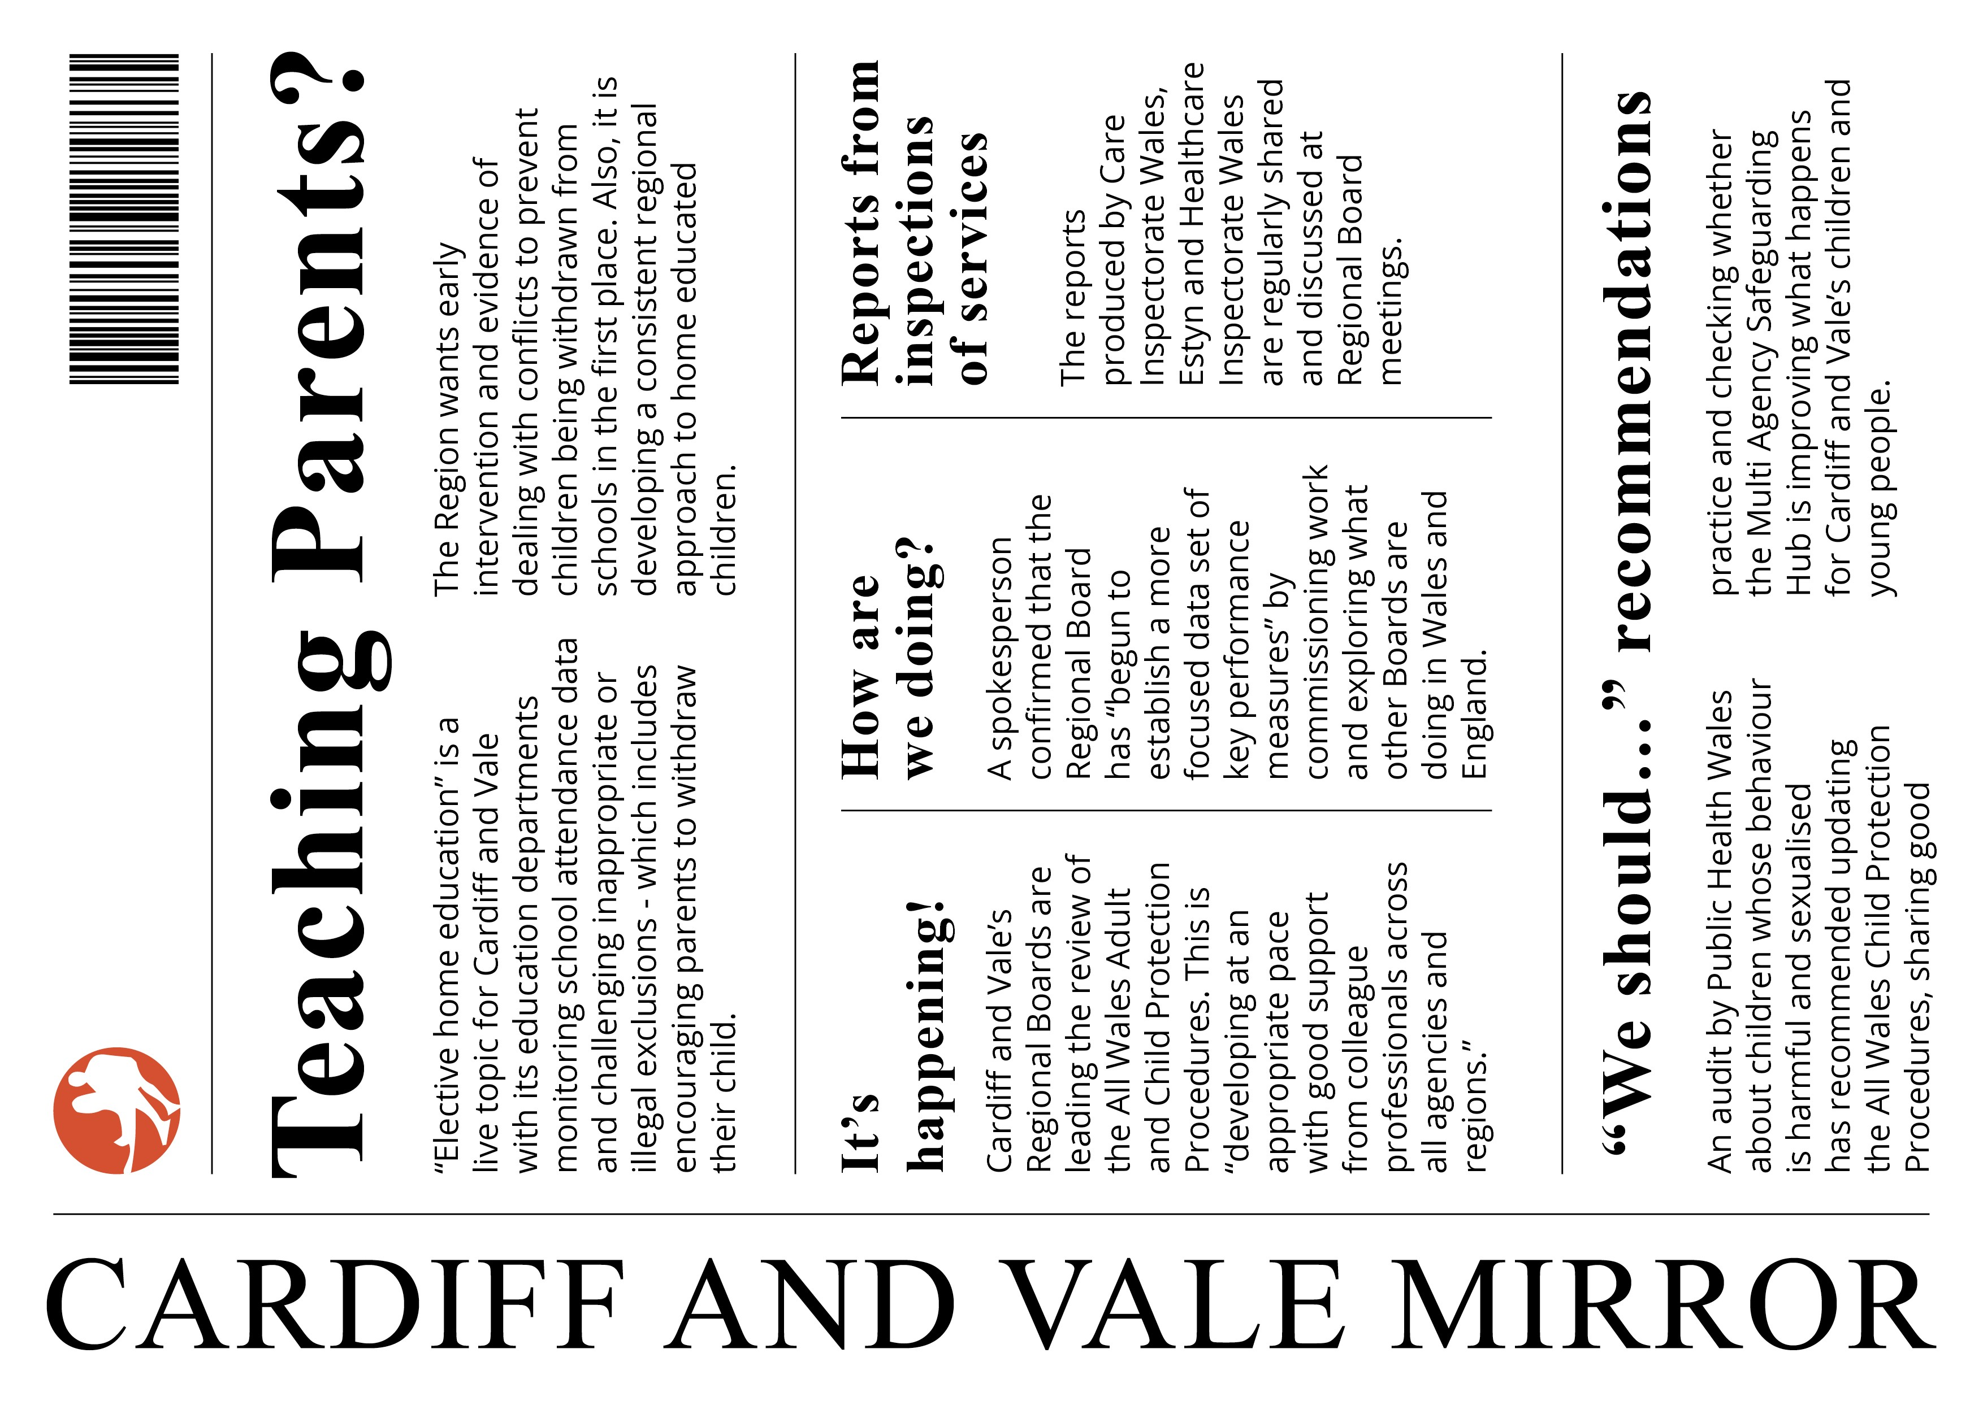
Reporting on the Adequacy and Effectiveness of Arrangements to Safeguard Children and Adults in Wales
Annual Report 2017-18
13

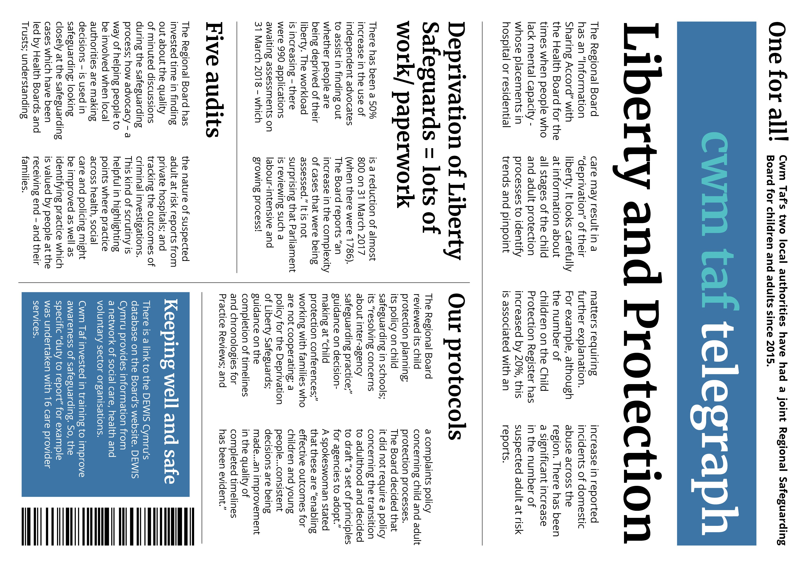
Reporting on the Adequacy and Effectiveness of Arrangements to Safeguard Children and Adults in Wales
14
National Independent Safeguarding Board Wales

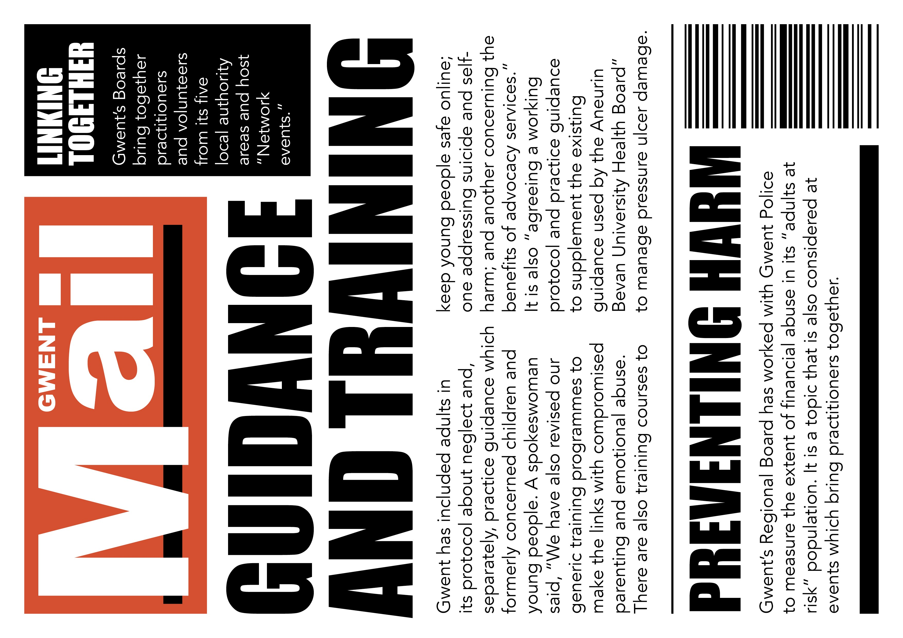
Reporting on the Adequacy and Effectiveness of Arrangements to Safeguard Children and Adults in Wales
Annual Report 2017-18
15

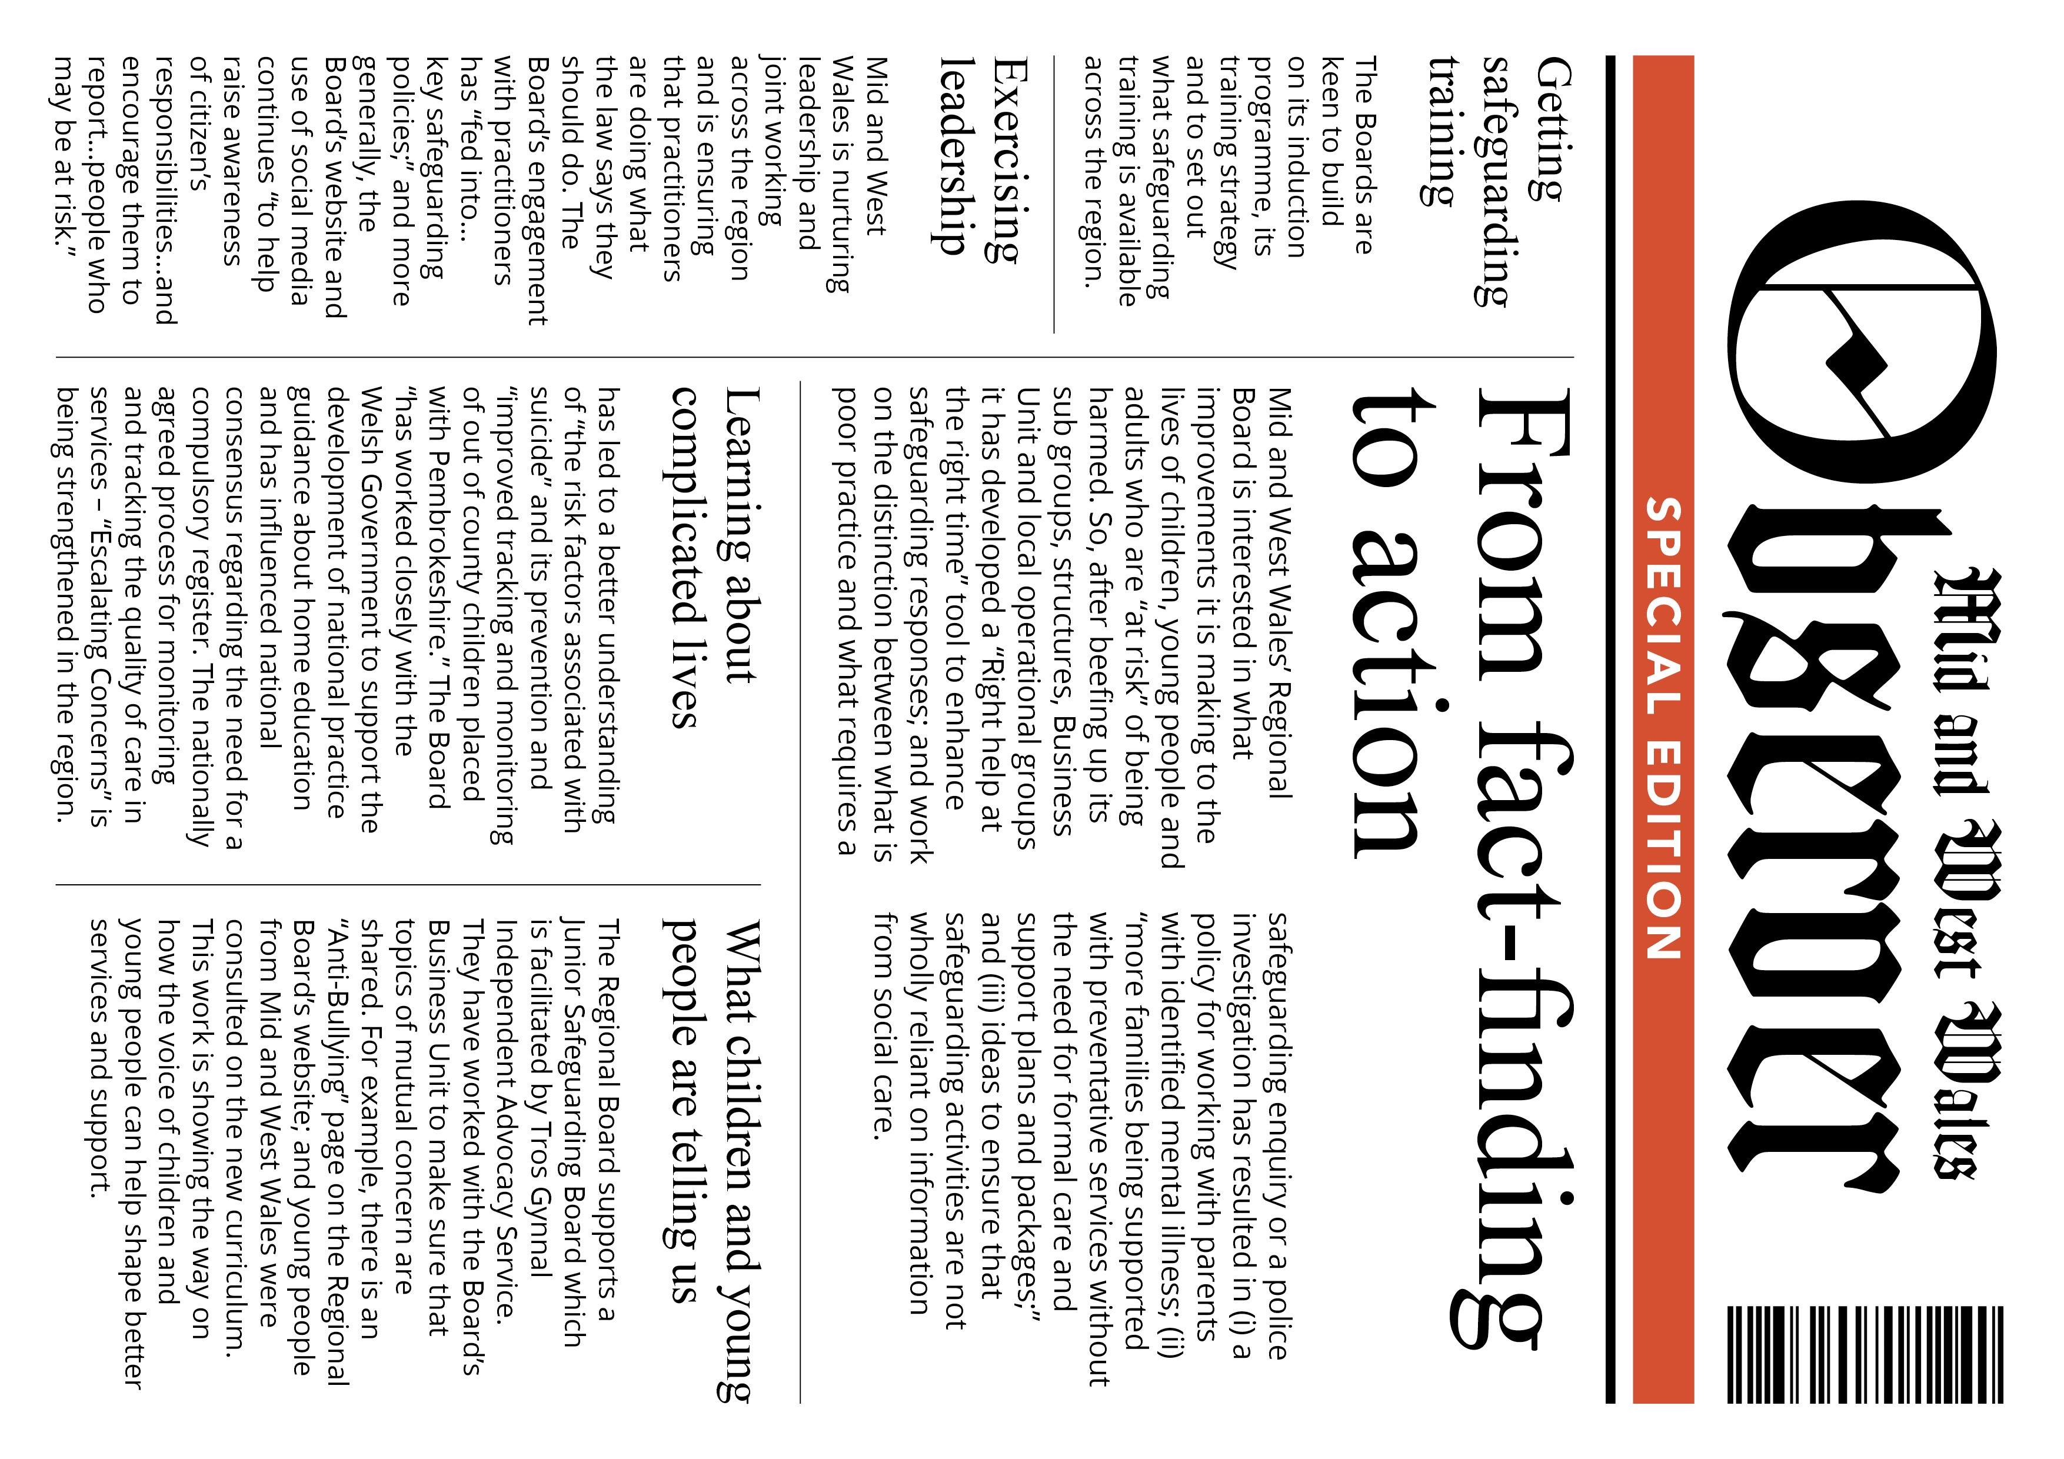
Reporting on the Adequacy and Effectiveness of Arrangements to Safeguard Children and Adults in Wales
16
National Independent Safeguarding Board Wales

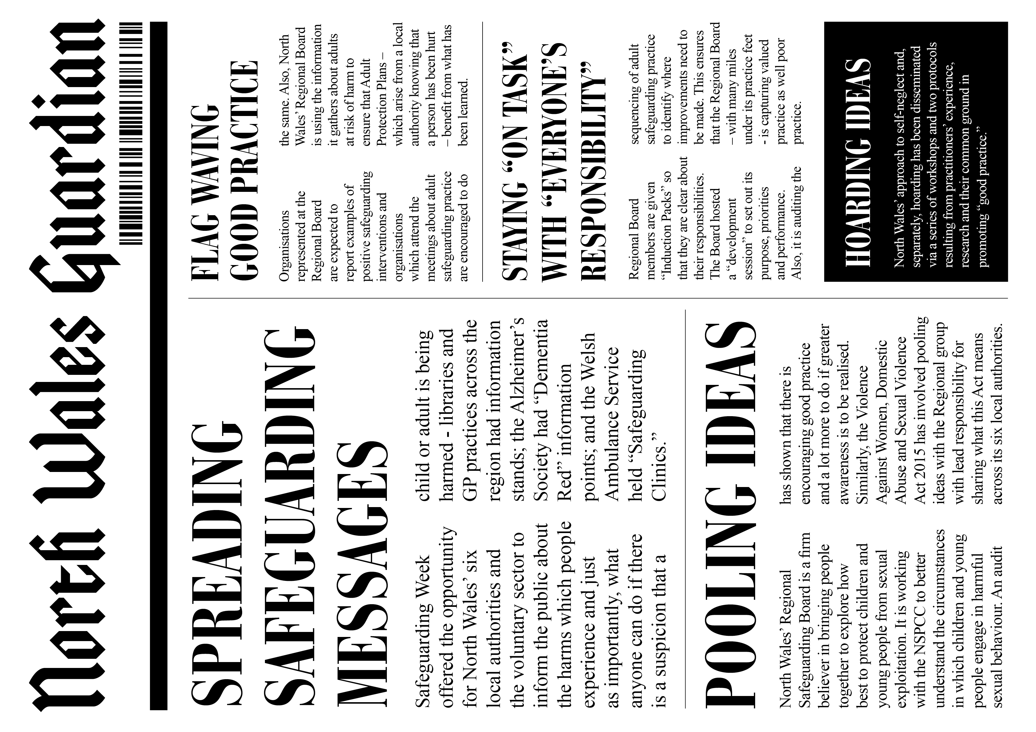
Reporting on the Adequacy and Effectiveness of Arrangements to Safeguard Children and Adults in Wales
Annual Report 2017-18
17

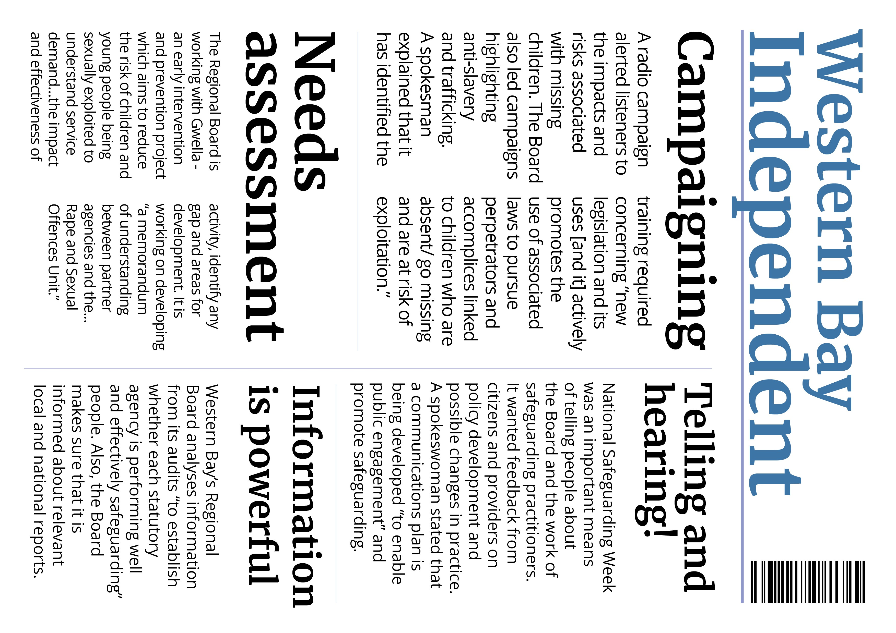
Reporting on the Adequacy and Effectiveness of Arrangements to Safeguard Children and Adults in Wales
18
National Independent Safeguarding Board Wales

Reporting on the Adequacy and Effectiveness of Arrangements to Safeguard Children and Adults in Wales

Annual Report 2017-18 19

How the Safeguarding Boards have collaborated in activities relating to their objectives
The allocation of resources to advance collaboration should mirror Boards’ priorities. Since not all Regional Boards addressed “how” they have collaborated in their annual reports, we can state that they are collaborating with an array of bodies as well as with each other via meetings for the Business Managers, meetings for the children’s and adults’ boards in the same safeguarding area and latterly, Chairs meetings. There is a willingness to join resources to deliver a defined service or product which may embrace the goal of mutual learning and benefit.

In the following imagined emails, we illustrate how each Board might describe their collaboration in
practice.
This email and any attachments may contain confidential material and is solely for the use of the recipient

DID YOU KNOW?
Coalitions, networks, movements, alliances, co-funding,
collective impact initiatives and campaigning may
all result from the question: how will children, young people and adults at risk of harm benefit from what we are doing?

Reporting on the Adequacy and Effectiveness of Arrangements to Safeguard Children and Adults in Wales

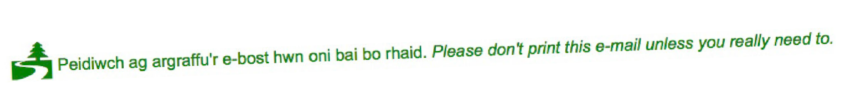20 National Independent Safeguarding Board Wales

This email and any attachments may contain confidential material and is solely for the use of the recipient

Reporting on the Adequacy and Effectiveness of Arrangements to Safeguard Children and Adults in Wales

Annual Report 2017-18 21

This email and any attachments may contain confidential material and is solely for the use of the recipient

22 National Independent Safeguarding Board Wales
This email and any attachments may contain confidential material and is solely for the use of the recipient

Requests the Regional Safeguarding Boards have made under S.137(1) for specified information
Reporting on the Adequacy and Effectiveness of Arrangements to Safeguard Children and Adults in Wales
Only Mid and West Wales made a S.137 (1) request “to a care provider to release information to assist the completion of an Adult Practice Review.” The request produced the information.

DID YOU KNOW?
S.137 (1) requests have been made on only two occasions since 2016.

Reporting on the Adequacy and Effectiveness of Arrangements to Safeguard Children and Adults in Wales

Annual Report 2017-18 23

Achievements the Safeguarding Boards made during the year
It is not clear that all the Regional Boards have a shared understanding of what best exemplifies safeguarding achievements. Two Boards did not specifically address the topic. We have included reference to mistakes/ obstacles to progress since there is learning from these and the Regional Boards concerned are developing more effective responses.

One Regional Board noted that a Child Practice Review “was not published as a direct request of the Child Subject…” However, an order of the court is required because the statutory regulations state that it is a function of Boards to “make the practice review report publicly available” (4 (4) (l)).

Cardiff and Vale
- is leading the review of the All Wales Adult and Child Protection Procedures -
recognises that the annual plans for 2017-18 “required development”
- knows that there are some areas of safeguarding practice that “have not had the attention they require”
- is involved in the development of the ‘Suicide and Self-Harm Prevention Strategy’ following a presentation to the Board in November 2017.
- Public Health Wales carried out a multi-agency re-audit of children who have harmful sexual behaviour.
- launched a safeguarding policy for Mosques and other Islamic Studies Settings during National Safeguarding Week in partnership with the Muslim Council of Wales. The success of this engagement now provides a basis
for engaging the communities in similar developments concerning adult safeguarding and this has been well received by local leaders.

24 National Independent Safeguarding Board Wales

Cwm Taf
Reporting on the Adequacy and Effectiveness of Arrangements to Safeguard Children and Adults in Wales
- the National Probation Service referred a man who was intending to return to live with his partner following a prison sentence for having harmed her. A Domestic Violence Advocate worked with his partner and supported her “in her new found determination to remove herself from the relationship”
- was praised for promoting contact between a father with mental health problems and his children. Child protection procedures commenced when a GP alerted the Multi-Agency Safeguarding Hub to the man’s mental deterioration
- its “life journey work” with siblings with additional learning needs enabled them “to understand the court process and the decisions that had been made about them” and allowed them to express their wishes and feelings about future contact with [their birth] family
- when a nursing home sought a Deprivation of Liberty authorisation for woman with “severe dementia” her considerable wealth was revealed. Although no one had the authority to manage this for her, a relative was stealing from her bank account. The assessor arranged for the services of an advocate, a solicitor took over the
management of the woman’s financial affairs, the safeguarding team ensured that [her] money was safeguarded and the relative was arrested.

Reporting on the Adequacy and Effectiveness of Arrangements to Safeguard Children and Adults in Wales

Annual Report 2017-18 25

Gwent
- has revised the Terms of Reference of the Board’s sub groups
- has fully translated websites
- collaborated with the regional Violence Against Women, Domestic Abuse and Sexual Violence partnership to deliver a conference
- produced the Boards’ strategic plan
- disseminated learning from Practice Reviews
- produced media clips about safeguarding and Board approved training packages
- co-opted a member of Gwent Citizen’s Panel onto the Engagement and Communication Group
- streamlined the Domestic Homicide Process across Gwent
- shares information across all safeguarding agendas at Local
Safeguarding Network meetings and practitioner forum events
- has developed a joint Quality Assurance Framework for both Boards
- is being advised by front line practitioners and services users and families

26 National Independent Safeguarding Board Wales

Mid and West Wales
Reporting on the Adequacy and Effectiveness of Arrangements to Safeguard Children and Adults in Wales
- hosted an event during February 2018 for both Regional Boards, which discussed the challenges concerning children’s services in Powys with a view to preventing a recurrence
- was prompted by the death of a home educated child to advocate for the introduction of legislation to better safeguard children who are electively home educated and ensure that the “small number of unseen children” are seen
- the death of a young person who was “Looked After” resulted in an Extended Practice Review which highlighted the need to improve multi-agency care planning for care leavers. This young person and others resulted in the Board commissioning research from Cardiff University into the region’s “probable suicides.” This resulted in dissemination events across the region and a concise report for practitioners was launched during National Safeguarding Week: “The importance of information being available to vulnerable children and young adults, their families and professionals as to where they can get help, and the importance of promoting positive mental well-being” is a valuable finding
- addressed the topic of online abuse and exploitation during National Safeguarding Week 2017. A conference supported by Dyfed Powys Police sought to raise awareness of methods of abuse and exploitation of children and adults
- prioritised connecting with young people via the Junior Safeguarding Board, Youth Groups and Youth Services – and learning about their priorities. Dyfed Powys Police carried out a mental health awareness raising campaign and Hywel Dda
University Health Board worked with Hafan Cymru highlighting the
impact of domestic abuse on children
- the success of activities over National Safeguarding Week was the impetus to extend the task of planning for the next safeguarding week corporately, within organisations, and externally with specialist third sector agencies.

Reporting on the Adequacy and Effectiveness of Arrangements to Safeguard Children and Adults in Wales

Annual Report 2017-18 27

North Wales
- took action after three Adult Practice Reviews highlighted self- neglect. Practitioners with experience of working with people who self-neglected were invited to share their insights and shape practice. A case study captures the resulting approach: a war veteran with a head injury, epilepsy, mobility problems, post- traumatic stress disorder, who was misusing alcohol declined
to accept any continuous support, even though he had been supported through “many” crises. A social worker encouraged him to accept help. Telecare was installed and he accepted daily
support calls to assist with meal preparation and prompts to take his medication. He agreed to being referred to the substance misuse service.
- a regional approach to improving the detection of child sexual exploitation (CSE) and the interventions necessary has been agreed. It appointed the NSPCC’s CSE worker as a “critical friend” to its work programme
- a case study highlighted the circumstances of a girl with poor school attendance whose experience of being parented was inconsistent.
A social worker worked with the girl and her parents to ensure that they knew the signs of drug use. North Wales Police put in place
a Child Abduction Warning Notice because of the influence of an older man who was the child’s supplier. Both Boards’ case studies highlight the critical role of professional, trusting relationships, and “persistent and consistent” practice.

28 National Independent Safeguarding Board Wales

Western Bay
Reporting on the Adequacy and Effectiveness of Arrangements to Safeguard Children and Adults in Wales
- has learned from the lessons identified through a review of [clinical] investigations which took place within the Health Board. These arose from a safeguarding referral and investigation by South Wales Police, a judicial process and the referral of a number of nurses to the Nursing and Midwifery Council
- has developed a partnership reporting framework to allow the Community Safety Partnerships to share information and updates regarding Domestic Homicide Reviews
- the significant cost associated with the medical interventions for Deprivation of Liberty Safeguards assessments has been highlighted
- the two “prisons, a young offenders institute and a children’s secure home are in Western Bay so Governors from Parc Prison and HMP Swansea are Board members
- a reduction in the overnight detention of children and young people at police stations has been achieved by cooperating with local foster carers and children’s homes
- has ensured the delivery of mandatory Violence Against Women Domestic Abuse and Sexual Violence training across agencies
- receives information about unexpected child deaths
- has contributed to awareness raising about the recruitment and exploitation of young people in drug dealing

Reporting on the Adequacy and Effectiveness of Arrangements to Safeguard Children and Adults in Wales

Annual Report 2017-18 29

DID YOU KNOW?
Asking Board Colleagues - “What three things have we done that have had - and will have - the strongest influence on the lives of children, young people and adults known to safeguarding services?” - will be helpful in sorting the breakthrough achievements from process refinements.

30 National Independent Safeguarding Board Wales

The extent to which Safeguarding Board members contributed to the Boards’ effectiveness
We observed in our report of 2016-17, “It is not known whether or not agencies invited colleagues from different sectors to co-author the assessments of their contributions.” This year we note that individual agencies continue to assess their own contributions and/or judgements are made on the basis of (i) “support” to the Regional Boards; (ii) roles within the Regional Boards, typically Vice-Chairing; (iii) membership of the Regional Boards’ sub groups and associated Chairing or Vice-Chairing roles; (iv) as Child/ Adult Practice Reviewers and/or panel members; (v) presenters of
Reporting on the Adequacy and Effectiveness of Arrangements to Safeguard Children and Adults in Wales
information to the Boards; and (vi) participants at learning events and development days for example. We do not reproduce these. We note however that Mid and West Wales’ states in its report of Powys’ Children’s services’ attendance and engagement have been “inconsistent…along with Powys’ initial unwillingness to be part of the Mid and West Wales’ Regional Violence Against Women, Domestic Abuse and Sexual Violence Strategic Board...”

What we set out are examples of the contributions of single agencies or agencies working together to engage with children, young people and adults - agencies which recognise the importance of professional attentiveness and personal relationships. Getting mediating structures and processes in place, without reference to the implications for people known to safeguarding professionals, may be less successful in reaching hearts and minds. As Jenny Williams, the Chair of North Wales’ Children’s Board noted, Looking back...we have had a general period of stability and this has paid dividends in the work streams and in our effectiveness. It is however often easy to forget that we must go beyond this and remember that children, young people and families are the heart of some of the most sensitive and intense work that we undertake as safeguarding agencies. What remains with me are the heartfelt stories we are privileged to hear…

DID YOU KNOW?
The best of safeguarding cultures are outcome focused and well-led. They build on shared values and purpose, are willing to win trust, to track results and allow staff discretion.

Annual Report 2017-18 31
Reporting on the Adequacy and Effectiveness of Arrangements to Safeguard Children and Adults in Wales

32 National Independent Safeguarding Board Wales
Reporting on the Adequacy and Effectiveness of Arrangements to Safeguard Children and Adults in Wales

* https://www.stonewall.org.uk/workplace-equality-index (accessed 1 August 2018)
** http://www.kivaprogram.net/wales (accessed 1 August 2018)

Annual Report 2017-18 33
Reporting on the Adequacy and Effectiveness of Arrangements to Safeguard Children and Adults in Wales

34 National Independent Safeguarding Board Wales

An assessment of how the Safeguarding Boards used their resources in exercising its functions or achieving its outcomes
The total expenditure of the Regional Boards ranges from £133,842.00 to £355,000.00. A detailed assessment is still well over the horizon because of the variable information supplied by the Regional Boards. For example, Cardiff and Vale and Gwent identify the cost of Practice Reviews (£39,000.00 and £8,000.00 respectively); (i) Mid and West Wales and (ii) North Wales identify the costs of (i) travel/ venues and (ii) travel (£3,795.00 and £2,496.11 respectively); Cardiff and Vale and Cwm Taf cite “room/ venue hire” and “premises” (£2,956.83 and £6,360.00 respectively); Western Bay has drawn on reserves of £36,316; Gwent’s budget for “training programmes” is £22,000.00; and Mid and West spent £26,200.00 “on commissioning services and/or training, which included…research into probable suicides, consultation with Pembrokeshire People First on the annual report, facilitation of the CADW Junior Board and the regional young person’s advocacy service with Tros Gynnal and bespoke training on working with difficult, evasive and challenging families.”
Reporting on the Adequacy and Effectiveness of Arrangements to Safeguard Children and Adults in Wales

Business Units receive most of the funding. The tables below reveal variation in Business Unit funding across the Safeguarding Board Areas.

Three Regional Boards included the following statement in their annual reports, without citing the
source:

“It is acknowledged that resources used to support the work of the Regional Safeguarding Board are not confined or restricted to financial contributions from statutory partner agencies. The Regional Safeguarding Board Chairs, Executive Board Members, Sub Group Chairs and members provide
a significant amount of time to support the Board and its work. This is often in addition to their identified professional roles and day to day responsibilities. The variable and diverse nature of the Board’s work makes this difficult to report on within a quantifiable and measureable resource context and is not always obviously visible to other professionals and agencies. The process, management and publication of Child and Adult Practice Reviews, the development of regional protocols and policies are all examples of projects that require high levels of professional input, knowledge and expertise.”

DID YOU KNOW?
Expenditure reveals nothing of the
relationship of cost to benefit

Reporting on the Adequacy and Effectiveness of Arrangements to Safeguard Children and Adults in Wales

Annual Report 2017-18 35

Mid and West Wales and Western Bay confirm the local authority and health funding as 60% and 25% respectively. It is not known whether all statutory funding partners are prodding the Regional Boards to

- nest the annual plans with foresight and attention to the long term?
- consider what resources will be deployed if a Board is not achieving the targets set out in annual plans?
- connect the skills and knowledge of particular individuals to specific tasks?
- invest in new knowledge to improve future performance?
- connect funding to outcomes at different levels e.g. the child/ adult at risk; the persons alleged to be responsible for the harm; the services and workforce; the commissioners; the national agenda?

Funding for the Regional Boards in 2016-17

Safeguarding Board Area | Overall resource | Business Unit
Cardiff and Vale | - | -
Cwm Taf | £176,010.00 | -
Gwent | £355,000.00 | £289,000.00
Mid and West | £110,058.46 | £ 73,343.41
North Wales | £218,562.00 | £173,148.00
Western Bay | £185,323.00 | £138,023.00
Funding for the Regional Boards in 2017-18

Safeguarding Board Area | Total expenditure | Business Unit
Cardiff and Vale | 133,842.27 | 88,429.67
Cwm Taf | 191,282.00 | 165,192.00
Gwent | 355,000.00 | 289,000.00
Mid and West Wales | 134,642.00 | 92,083.00
North Wales | 218,568.53 | 123,275.10
Western Bay | 185,326.00 | -

36 National Independent Safeguarding Board Wales

Underlying themes in the way the Safeguarding Boards exercised their functions as shown by an analysis of cases dealt with and any changes it has put into practice
The learning arising from Practice Reviews, Domestic Homicide Reviews, research, audits and the Regional Boards’ “data” are all rich sources of themes. Four Regional Boards set out the “macro themes” – Mid and West Wales and North Wales’ Board presented case studies to exemplify themes.
Reporting on the Adequacy and Effectiveness of Arrangements to Safeguard Children and Adults in Wales

DID YOU KNOW?
If Regional Boards were to “track” over time the changes which have resulted from particular events and themes, they would be in a strong position to identify effective changes.

Reporting on the Adequacy and Effectiveness of Arrangements to Safeguard Children and Adults in Wales

Annual Report 2017-18 37

 | Themes concerning children | Changes put into practice
Cardiff and Vale | - Complaints procedure  - Relevant organisational  reports/ inspections | - Aligning this with the adults’ procedure  - Sharing and discussing these at the Board
Cwm Taf | - Children on the Child Protection Register who have been previously registered  - Children on the Child Protection Register who are also looked after  - Children from particular  communities | - Monitoring these children  - Acknowledging the “exceptional circumstances” so subject to “challenging cases” process  - Training about Honor Based Violence; and working  with Traveller communities – and monitoring
Gwent | - Research about children and young people staying safe  - Working with uncooperative families  - Young people’s mental health | - Keeping young people safe online: a strategic priority;  - Reviewing and strengthening guidance  - Developing a training course with professionals in primary mental health services
Mid and  West Wales | a. Supporting effective challenge and professional accountability | - Strengthening clauses and wording of commissioning contracts with care providers to compel providers to cooperate with safeguarding reviews; improving communication and information sharing;  - Using “Signs of Safety” e.g. a couple who would not engage with ante-natal appointments during two pregnancies (their first child had been adopted by  another family and their second died) were encouraged to work with the social worker and midwife and identify their strengths and difficulties. Now they actively engage and accept that their family needs support
North Wales | - Children on the Child Protection Register for more than 18 months;  - parents who have experienced poor parenting themselves | - Having a clear rationale; professionals reminded that their judgement contributes to risk assessments and decision-making; reflected in child protection training  - A positive case study involving the “Edge of Care” team – providing 15-20 hours of weekly support pre and post birth - enabled a baby on the Child Protection Register to remain with her parents. The family have agreed to continue to accept support
Western  Bay | Families responsible for the non- accidental injury of an infant and the sexual abuse of a child | Ensuring that families have information about each stage of the child protection process; and reminders to professionals to be watchful and attentive to a child’s history and family dynamics; and the bruising of “frequent attenders” should be regarded with suspicion

Reporting on the Adequacy and Effectiveness of Arrangements to Safeguard Children and Adults in Wales

38 National Independent Safeguarding Board Wales

 | Themes concerning adults | Changes put into practice
Cardiff and Vale | - Complaints procedure  - Relevant organisational  reports/ inspections | - Aligning this with the children’s  - Sharing and discussing these at the Board
Cwm Taf | - Delays in the adult protection process  - Feedback from the police concerning ongoing criminal investigations | - audits evidencing “improvements;” and “health have evidenced that relevant documentation is consistently completed”  - “…there has been an improvement”
Gwent | - “In search of accountability”*  - Falls in older “at risk” people | - “Quality of care” - a strategic priority  - Reporting structures and pathways have been aligned with Health Board protocols
Mid and West Wales | a. Supporting effective challenge and professional accountability | a. Strengthening clauses and wording of commissioning contracts with care providers to compel providers to cooperate with safeguarding reviews; improving communication and information sharing
North Wales | - An elderly parent’s wish to accommodate/ live with a physically abusive adult son  - A bereaved man with autism living in the former family home befriended by unscrupulous and assaultive adults – with whom he drank alcohol  - A woman receiving in-patient mental health treatment told  a nurse that she was having an intimate relationship with a support worker | - Collaboration across sectors resulting in a “low level care package” included a leaflet drop to neighbors about domestic violence and how to report it  - An immediate protection plan involved a sympathetic local hotel where the man was known; a placement in a neighbouring town was arranged which is proactive in involving the man in the community  - the police and adult safeguarding were informed and the suspect was suspended and prosecuted; the woman was supported to present evidence at the trial
Western Bay | - the unsafe grouping of learning disabled residents resulting in a sexual assault; a slow police response and  loss of forensic evidence; and communication with relatives during crises  - the conviction of a health board worker for murder who had been suspended following allegations of sexual assaults of patients | - Compatibility risk assessments based on what is known of a new resident’s history; new residents  considered by the professionals managing placements; training for police officers; attention to communications  - recruitment processes; safeguarding processes; incident reporting and escalation procedures; and attention to patient experience

* https://gov.wales/topics/health/publications/socialcare/reports/accountability/?lang=en

Reporting on the Adequacy and Effectiveness of Arrangements to Safeguard Children and Adults in Wales

Annual Report 2017-18 39

When and how children or adults exercised an opportunity to participate in the Boards’ work and how this contributed to the Boards achieving their outcomes
In the National Board’s first annual report (2016) we reported that the Chairs of Regional Boards saw engagement “with those using safeguarding services was work in progress in most localities. It is resource-intensive because it has to be continuous.” In 2018, there is hesitancy in most Regional
Boards’ accounts of participation with some still focused on the preparatory actions with the interests
of adults who are known to services limited to episodic fact-finding. Introducing new people to the dynamics of working arrangements is not a simple matter – new demands may be made and considerations raised. The Boards approach participation in different ways and do not generally reveal how they engaged young people and adults in identifying the matters that they wanted to
confront – looking within or beyond themselves for new knowledge and skills. Some Boards cite the participation of professionals, which was unexpected. As Mid and West Wales demonstrates however, once the commitment is made, participation is continuous rather than time limited.

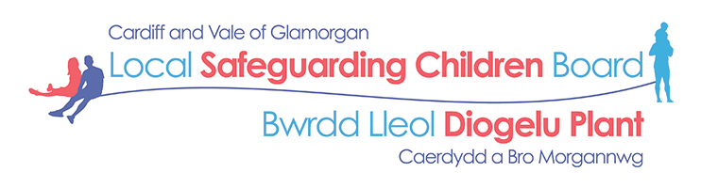

Cardiff and Vale’s Communication and Engagement Sub Group for both Boards has met on four occasions and has reviewed and updated its Terms of Reference and the Communication Strategy; it has updated and redesigned its website and has launched a newsletter.

DID YOU KNOW?
“Participation may be imperfect, may have its drawbacks, but still be better…than doing without it. The problem is not simply who is affected by participation and how, but also who is affected by its absence…”*
* Richardson, A (1983) Participation. Concepts in Social Policy 1, London: Routledge and Kegan Paul

40 National Independent Safeguarding Board Wales

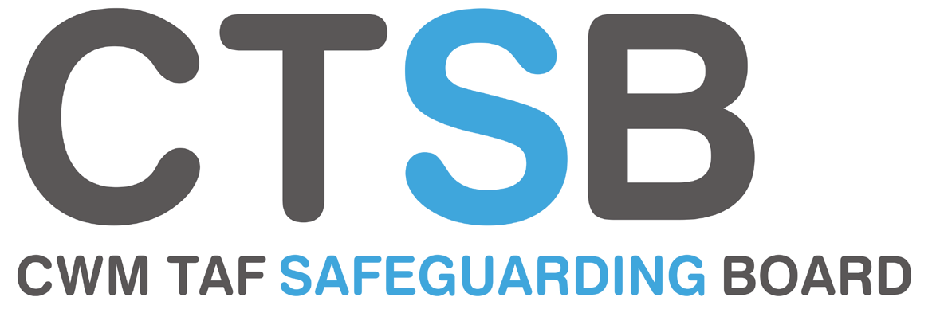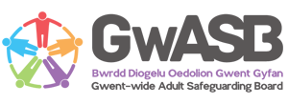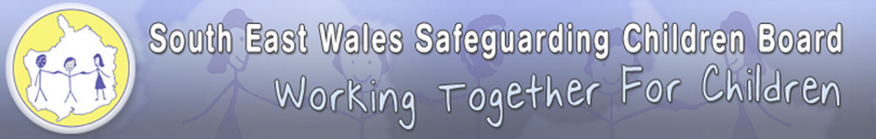Cwm Taf combined a number of engagement activities and consultation with the people who use services throughout the year - plus professionals - and hosted events during Safeguarding Week 13-19 November 2017 e.g. “Events specifically for children and young people included safer alcohol use, homelessness, mental health, healthy relationships, Lesbian, Gay Bisexual Transgender and respect.” Thirty young people participated in a theater workshop exploring grooming and sexual exploitation; the Children’s Commissioner contributed to a student conference about “How to cope with everyday life;” and a “Wellbeing day” was hosted for members of the public, service users, carers and professionals. The Board’s website contains information “to raise awareness of safeguarding;” the Child/ Adult Practice Review process involves individuals and families and takes account of their feedback; and the Multi-Agency Safeguarding Hub’s “annual consultation survey” endorses its continuation. A survey concerning the Deprivation of Liberty Safeguards resulted in “an active offer approach to advocacy support for advocates and relatives assisting adults who do not have capacity.”
Reporting on the Adequacy and Effectiveness of Arrangements to Safeguard Children and Adults in Wales

Gwent’s Engagement and Communication Group made links with existing groups and forums to ensure that it involved “the most relevant group of individuals with each project we undertake.” For example, a parenting network group was invited to shape “the content of the website pages for parents and carers;” and “the website Task and Finish group…consulted with professionals and volunteers at various levels about content.” A Go Girls and Brothers interactive drama production about child sexual
exploitation was “rolled out” in schools; and “information from Gwent Drug and Alcohol Service [was used] to inform the production of our Quality Assurance Framework.” The Board has “links” with the regional “provider forum,” Registered Social Landlords and “a group of survivors through collaboration with Violence Against Women, Domestic Abuse and Sexual Violence. Also, it was “project managing a group of service users to work with advocacy providers” and families are involved in reviewing processes.

Reporting on the Adequacy and Effectiveness of Arrangements to Safeguard Children and Adults in Wales

Annual Report 2017-18 41

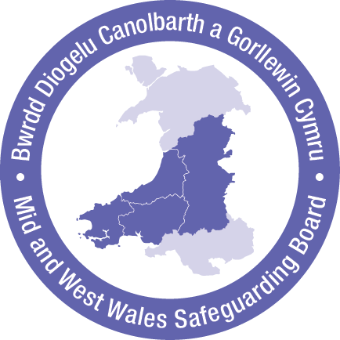Mid and West Wales’ Junior Regional Safeguarding Board attended an Executive Board meeting during July 2017 at which it discussed the importance of strengthening the Personal and Social Education part of the school curriculum and beefing up important life skills such as how to balance a budget. The Junior Board made a plea to shift the focus of education from the stress of achieving grades to opening doors. The young people made a bid for anti-bullying to be a continuing theme rather than a topic for Safeguarding Week. The rawness of bullying is familiar to Carmarthenshire’s Youth Council. It launched a mental health pledge arising from the experience of teenager Harriet Alsop-Bingham whose experience was so extreme that she began to self-harm. Her experiential
knowledge that starting a conversation can be transforming encouraged the Youth Council to launch #StoriHarriet. This led to a youth conference about mental health, It’s a bad day not a bad life. Harriet won Carmarthenshire Radio’s Child of Courage Award in 2017. Mental health was a topic which Pembrokeshire’s Junior Safeguardians also identified as important in its consultation with over 3000 young people.

The ideas of the Junior Safeguarding Board were shared with the regional and national Directors of Education in Wales – and during February 2018, the Junior Board was advised that they had influenced the national work on the new curriculum. The Junior Board highlighted the topic of
substance misuse and explained that they favoured facts over “hysterical propaganda” – calling the attention of the Regional Board and educators to the presentation of public health matters to young people. The Junior Board was invited to comment on the Annual Plan 2018-19. The young people explained that they wanted their own plans to be connected to the Regional Board’s plans so that both Boards could share priorities. One Junior Safeguardian, Bethany Roberts, is a member of the UK Youth Parliament and she won Radio Pembrokeshire’s Young Achiever, Volunteer of the Year award for her commitment to young people and children’s rights.

Powys’ “Eat Carrots Be Safe from Elephants” and the Junior Safeguardians advised the Regional Board that they wanted the Boards’ website to reflect the interests of young people. This resulted in dedicated pages, a Facebook page and Twitter accounts “with much interaction.” The “Eat carrots…” group also sought the inclusion of Lesbian, Gay, Bisexual, Transgender, Queer Questioning and other identities (LGBTQ+) in sex education and understanding the Child Protection and Court process for example. Ceredigion’s “Ser Saff” and Youth Service held a safeguarding poster design competition which attracted 50 entries. These focused on cyber safety, bullying and sexting – with the poster
and winning strapline Don’t be mean behind the screen designed by Tyler from Ysgol Penglais and Penparcau Youth Club. Ceredigion’s Youth Service worked with Aberystwyth University and Ysgol Gyfun Gymunedol Penweddig’s drama department to create a short film about online safety.
It came second in the Welsh Government’s Safer Internet Day 2018 competition. During National Safeguarding Week, Pembrokeshire’s Junior Safeguardians hosted a conference about online abuse and exploitation.

Mid and West Wales hosted focus groups across the region with 56 survivors of sexual violence and abuse. Their experience and ideas fed into its joint strategy in line with the Violence Against Women Domestic Abuse and Sexual Violence Act 2015.

Finally, the Boards consulted with Pembrokeshire People First “to work towards developing an easy read version of the Annual Plan” – and acknowledged that the participation of adult service users requires attention.

Reporting on the Adequacy and Effectiveness of Arrangements to Safeguard Children and Adults in Wales

42 National Independent Safeguarding Board Wales

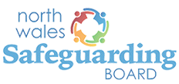

North Wales commissioned a drama about child sexual exploitation which was shown in schools across the region and was favourably evaluated. The Region has created an Engagement and Participation subgroup.

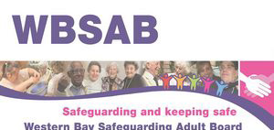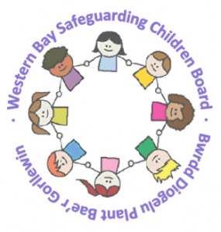

Western Bay’s Boards routinely invite people to participate in it work through the engagement of families [who are] subject to Practice Reviews. The Adult Board links with the Citizen’s Panel which identified the need for improvements on our website. The Western Bay Area Planning Board hosted an “engage
to empower” event for people who misuse substances, or used to, and have mental health problems. This identified challenges concerning the integration of services and the competency of the workforce for example. The resulting ideas informed the work of the Dual Diagnosis Implementation Group.

Reporting on the Adequacy and Effectiveness of Arrangements to Safeguard Children and Adults in Wales

Annual Report 2017-18 43

The number of Adult Protection and Support Orders (APSO) which were applied for in the Safeguarding Boards’ areas and how effective they were
For the second year, no Regional Board reported use of the new legal tool - the Adult Protection and Support Order. APSOs enable an authorised officer, and any other person specified in the order, to enter “premises” to speak to an adult suspected of being at risk of abuse or neglect in private,
to establish whether or not they can make decisions freely, to assess whether the person is an adult at risk and establish what, if any action should be taken. The statutory guidance defines “premises” as including domestic premises, a residential care home, a nursing home, a hospital or any other building, structure, mobile home or caravan in which the person is living.1

We have gathered that APSOs may be seen as positive tool if access to an adult has previously been
frustrated. However, there is little enthusiasm for using them:
…they are a little toothless… great for getting you through the door to see someone, but what then? As a comparison, if we were concerned enough about somebody’s mental health for example, but were struggling to gain access to that individual, there are means via the Mental Health Act 19832 to gain entry and remove a person for assessment. The APSOs don’t give us the same powers and often matters are resolved without or before needing such an order.
Gaining access to a suspected adult at risk is merely a part of the problem; if they have been liv- ing in a toxic or coercive environment for long enough, it would in my view take more than a quick triage style chat/assessment to uncover whether there are any risks to the individual. It would be a challenge to get the individual to readily disclose issues to a Social Worker for example that they may not yet have any sort of rapport with. If there was a power to remove (which of course would present its own difficulties) that might give sufficient time and distance away from those posing a risk for the adult at risk to be able to disclose concerns.
John Williams3 acknowledges that assessing whether or not a person is deciding freely is a complex task because of the difficulties of immediately identifying coercive behaviour. He notes that it is unclear whether or not an APSO allows multiple entries until its purposes are achieved. The APSO does not give authorised officers ongoing powers of entry even though a person may be left with someone who is harming them, who may be enraged by the intervention and render the person at greater risk. This must be a consideration of justices of the peace when hearing applications – and of Welsh Government as it considers whether or not limited powers of intervention such as temporary removal for assessment or temporary barring would render the APSOs a more useful legal tool.
DID YOU KNOW?
Invoking an Adult Protection and Support Order is a significant Human Rights decision. The National Board learned that an APSO application had been made – outside of the Regional Boards’ reporting period for its annual report – via a Professor of Law, via the office of the Older People’s Commissioner…

- Welsh Government (2016) Vol 4 – Adult Protection and Support Orders, para1.14
- S. 135: Where a person suffering from a mental disorder is being ill-treated or kept otherwise than under proper control, or is living alone and unable to take proper care for himself, a magistrate may issue a warrant authorising a police officer to enter, if need be by force, premises and remove him to a place of safety
- Williams, J. (2017) Adult Safeguarding in Wales: one step in the right direction The Journal of Adult Protection, 19 (4) 175-186

44 National Independent Safeguarding Board Wales

Any information or learning the Safeguarding Boards have disseminated or training they have recommended or provided
Since abuse is so detrimental to the health and well-being of individuals the Regional Boards are playing a part in enhancing people’s skills and extending their knowledge. Each of the Regional Boards has created training groups: Cardiff and Vale has a Training Subgroup; Cwm Taf has a Training and Learning Subgroup; Gwent has a Learning and Development subgroup. Mid and West Wales has a Regional Training Subgroup; North Wales has a Joint Training and Workforce Development Group; and Western Bay has a Joint Training Group. So they are ensuring that practitioners have access to different types and levels of safeguarding training.
Reporting on the Adequacy and Effectiveness of Arrangements to Safeguard Children and Adults in Wales

The Regional Boards were represented at three, two-day training courses concerning the Practice Review process. This was commissioned by the Welsh Government. Similarly, the Regional Boards have attended Social Care Wales’ training concerning Adult Protection and Support Orders.

The Regional Boards’ websites contain “basic” information such as what the Boards do, who they involve, how to report abuse, information about safeguarding events and Practice Reviews for example.

Three Regional Boards have embarked on freestanding training needs analyses. Cardiff and Vale do not detail its analysis. Mid and West Wales has developed a Regional Training Strategy as a result of its analysis. It acknowledges the diverse professional and organisational specific training and
is addressing the necessity of partner agencies understanding their duties and responsibilities as outlined in the Social Services and Well-being (Wales) Act 2014 and the Violence Against Women, Domestic Abuse and Sexual Violence Act 2015. North Wales’ has revealed the limited control over who can/ does deliver safeguarding training and the absence of agreed standards to evidence competence/ knowledge and has noted the need for training in relation to risk, training about self- harm and joint investigation training.

The topics of Child Sexual Exploitation and the Violence Against Women, Domestic Abuse and Sexual Violence Act are consistent features of Regional Board training across Wales. Otherwise, the training reported at the Regional Boards reflects such policing initiatives as County Lines, the Welsh Government’s campaign to make Wales hostile to modern slavery and human trafficking4 plus such regional interests as: dementia care (Cwm Taf); suicide and self-harm (Gwent); working with difficult, challenging and evasive families (Mid and West); self-neglect (North Wales); and young people engaging in sexually harmful behaviour (Western Bay).

It is early days and the Regional Boards are demonstrating their willingness to attend events,
commission and deliver training and ask searching questions about standards for example.

4 Criminals/ gangs in the UK conducting their drug dealing across county boundaries and coercing then exploiting young people to deliver drugs and collect
the cash payments. The young people may be socially isolated, former “looked after” children and may have a physical or learning disabilities for example

Reporting on the Adequacy and Effectiveness of Arrangements to Safeguard Children and Adults in Wales

Annual Report 2017-18 45

During 2016-17, the National Board and Social Care Wales sought to establish a baseline of safeguarding training opportunities. The effort was unsuccessful. However, since it cannot be established from the 2017-18 annual reports whether or not (i) instruction-led, online or a mix of the two are mostly favoured; (ii) the training needs analyses were (a) coordinated and sought identical information, (b) combined individual as well as organisational needs, the case for an overview of Wales’ safeguarding training remains.

 | Learning and Training
Cardiff and  Vale | Has undertaken a “training mapping exercise” to see what training agencies are offering; it is developing a training register; and seeks to incorporate learning from practice reviews and safeguarding research into future training
Cwm Taf | Has delivered safeguarding training courses; it has increased the numbers of reviewers/ facilitators to undertake Practice Reviews; and undertaken Multi Agency Practitioner events
Gwent | Although its training is skewed towards safeguarding children, the process of addressing parallel adult safeguarding training has begun. It is proactive in providing “awareness raising training” to complement that of individual agencies; it has reviewed, revised and is piloting training modules; and it commissions training regarding specialist topics
Mid and West Wales | Has invested in developing its website to promote events, reviews and good practice; a training needs analysis; as well as making sense of organisations’ internal training frameworks
North Wales | Has undertaken a training needs analysis and over 30 organisations responded. This identified “gaps” principally concerning adult safeguarding. It acknowledges the challenges of quality assuring the competence and knowledge of trainers and is exploring: regionally agreed, “basic” training for providers and performance framework; and quality assured trainers
Western  Bay | Relies on Regional Board members to disseminate the learning arising from “audits and Practice Reviews.” It relies on a pool of agency based trainers including the three local authorities, South Wales Police and Women’s Aid for example

46 National Independent Safeguarding Board Wales

DID YOU KNOW?
There are four familiar “elephants in the room:”

Are training commissioners confident that the course content is closely aligned to people’s day to day work?
Reporting on the Adequacy and Effectiveness of Arrangements to Safeguard Children and Adults in Wales

Are training commissioners entering into agreements with individual learners and their organisations about specific learning needs?

Are learners encouraged to set out what changes they hope to make to their practice
after training?

Are organisations providing opportunities to
learners to use their skills and knowledge and provide examples (at a later date) of whether or not anyone is better off as a result
of their training?

Reporting on the Adequacy and Effectiveness of Arrangements to Safeguard Children and Adults in Wales

Annual Report 2017-18 47

How the Safeguarding Boards have implemented any guidance or advice given by the Welsh Government or the National Board
The Regional Boards send their Practice Reviews to the Welsh Government,5 the Chairs have regular meetings with the Welsh Government and the Children’s Boards have prioritised ways of tackling Child Sexual Exploitation (CSE).

 | Implementation of Guidance or Advice
Cardiff and Vale | The National Independent Safeguarding Board has run a number of events at which Cardiff and Vale have been represented…Board members address  recommendations from the National Independent Safeguarding Board and their own concerns surrounding the openness and ability to monitor any issues arising from all individual agencies
Cwm Taf | The conclusions contained in the National Board’s annual report were considered when developing this year’s annual report and have informed its structure
Gwent | The Gwent Boards have participated fully in national events…the project Board for the production of the All Wales Safeguarding Procedures, National Independent Safeguarding Board Leadership summit meetings…receive regular updates from the NISB link member in respect of practice such as Elective Home Education
Mid and  West Wales | …the National Independent Safeguarding Board…have supported the CYSUR in its continuing work on Elective Home Education…has considered and acted upon feedback and advice on how the Board can better demonstrate the good work undertaken and the positive outcomes achieved in the delivery of its annual report
North Wales | Re the National Independent Safeguarding Board report on Home Educated Children. A presentation was received at the Board and then shared with the local delivery groups
Western  Bay | The NISB summit was informative and inclusive and provided advice and guidance  on leadership

DID YOU KNOW?
Whenever someone tells us what to do and how to
do it we tend to respond with defensive defiance…

- Although The Safeguarding Board (General) (Wales) Regulations 2015, 4 (5) (k) states that Boards should “provide a copy of the practice review report and action plan to the Welsh Ministers and to the National Board” this is not yet embedded in practice

48 National Independent Safeguarding Board Wales

Other matters relevant to the work of the Safeguarding Boards
We have gathered the messages on the following postcards from the Regional Boards’ reports.
Reporting on the Adequacy and Effectiveness of Arrangements to Safeguard Children and Adults in Wales

Reporting on the Adequacy and Effectiveness of Arrangements to Safeguard Children and Adults in Wales

Annual Report 2017-18 49

As the number of services
in “Escalating Concerns”
is increasing (perhaps this
is useful safeguarding data?), the number of nursing and residential
homes is decreasing. You
state that “leadership and management” needs attention. Who is responsible for this?
Regards

Reporting on the Adequacy and Effectiveness of Arrangements to Safeguard Children and Adults in Wales

50 National Independent Safeguarding Board Wales

Our work on financial abuse (people being defrauded, ripped off, scammed, having their money/property misused)
has alerted us to new risks concerning gambling. How might we tackle these challenges in Wales?
Regards
Gambling Commission
and Banks

Westminster Government

The National Board’s support and advice to Safeguarding Boards with a view to ensuring that they are effective

Annual Report 2017-18 51

The National Board’s support and advice to Safeguarding Boards with a view to ensuring that they are effective
2

The National Board’s 2018-19 work plan has a strong sense of continuity with its previous work programme - which gave significance to the Social Services and Well-being (Wales) Act 2014 and to the best understanding of the National Board’s members. It has faith in hopeful ideas and fresh approaches. It has a long-term perspective and gives emphasis to the importance of ways of
communicating to better serve the twin goals of preventing children and adults from becoming at risk of abuse, neglect and harm and protecting children and adults who are at risk of abuse, neglect or other kinds of harm.

Our understanding of providing support and advice to Safeguarding Boards includes attention
to the agendas, plans and work programmes of the Regional Safeguarding Boards. Five members of the National Board have attended between 7-15 meetings of the Regional Safeguarding Boards since 2016. This has ensured grounding in their experience and familiarity with the enactment of their work programmes. It has also been a means of sharing ideas from elsewhere in Wales and the UK
for example.

Attendance at Regional Safeguarding Boards and scanning their annual reports has revealed the necessity of complementing the safeguarding information which features on Social Care Wales’ website to enhance “legal safeguarding literacy.” The NISB Wales Guide: Basic Legal Principles may be downloaded from the National Board’s website. This has been written by Abla O’Callagan, Laura Shepherd and Ruth Henke QC6. Also, since practitioners involved in safeguarding children and adults may be overwhelmed by the task of learning from criminal trials and key inquiries, the National Board is bringing together the lessons of significant Welsh cases which are likely to be remembered from the media and exploring how such a resource may be sustained and developed in the future.

During November 2017 the National Board and the Welsh Government hosted a conference: Safeguarding in Sport: Taking Responsibility – Taking Action, to acknowledge the extraordinary achievements of those people whose lives have been disfigured by abuse and who have triumphed in strength and dignity. Swimming, running, football, cycling, gymnastics and rugby and other physical activities are good for our minds, bodies and well-being. As well as the health benefits, sports teach us about trying, training, teamwork and winning or losing together. The self-confidence and self- esteem of children who enjoy sports and of talented sportsmen and sportswomen is tangible. It is thrilling to watch exceptionally accomplished sportsmen and women. Talented sportsmen and women add to the “feel-good” of a population and pride in international prestige. Their achievements inspire others and create a wider pool from which future champions may be identified. The event confirmed that the possession of exceptional sporting talents may result in recruitment by a talent “scout” and/ or one-to-one coaching by people who are renowned in their own right. These people enjoy prestige and considerable leverage over whether or not children and young people achieve success in their chosen sport. However, if coaches have an ulterior purpose, young lives can be capsized – and since the majority of sports are unregulated, there is a case for assertive campaigning.

- This text was consulted upon at a Legal Wales conference on 12 October 2018

52 National Independent Safeguarding Board Wales

Campaigning is essential as we work towards the common cause of safeguarding for everyone at risk of harm. The National Board, the Regional Safeguarding Boards and the Welsh Government have determined to strengthen and reinforce safeguarding consciousness by combining forces and developing inclusive campaigns, which make sure that there is space for people who are typically ignored to speak out. Our own consultations with individuals and groups throughout Wales and the UK has engaged our interest in:
The National Board’s support and advice to Safeguarding Boards with a view to ensuring that they are effective

  - “contextual safeguarding”7 which provides a framework for understanding the ways in which the efforts of parents, for example, may be undermined. The National Board is a member of its programme’s UK Influence and Advisory Panel;
  - indirect feedback from the relevant research. For example, we have been advised of three referrals to safeguarding by the Department of Law and Criminology Department at Aberystwyth University8 concerning three older people subjected to domestic violence. The referring professionals received no acknowledgement and no contact was made with the three people, even though safeguarding managers had been copied into the referrals. This left the task
of identifying third sector organisations and a health provider to a research team. The same researchers recalled an older woman who approached children’s safeguarding to report the circumstances of her grandchildren who were witnesses to domestic violence, she was told that referrals could not be received from third parties.9 This is wrong. Anyone may make a referral;
  - Wales’ new curriculum from 2022, Relationships and Sexuality Education, having contributed to
its rationale;
  - the activities of England’s network of Safeguarding Adult Board Chairs – which, inter alia, alerted the National Board to the 2017 publication, Safeguarding Adults: Scamming and Mental Capacity10 - which was shared with the Regional Boards;
  - commissioning campus based services for young people and adults with learning disabilities in
the UK;
  - learning from safeguarding practice in the UK and internationally. The National Board shared information about international safeguarding practice with the Welsh Government which arose from work with the Republic of Ireland’s Health Information and Quality Authority;11
  - the ESRC funded Safeguarding Adults and Legal Literacy (SALLY) programme12 which reinforced the importance of setting out Basic Legal Principles in Wales; and
  - the work programme of the Heads of Inspectorate Group – most particularly in matching audits of the work of multi-agency partnerships with multi-agency inspectorates; and delivering value.

- https://www.beds.ac.uk/ic/current-projects/contextual-safeguarding-programme (accessed on 1 September 2018)
- The Dewis Choice: Building Justice Options with Older People
- Older Survivors of Domestic Abuse: A forgotten Population 3-6 September 2018, Aberystwyth University, Department of Law
- By Fenge, L-A., Lee, S. and Brown, K., as part of the Post-Qualifying Social Work Practice series, London: Learning Matters, Sage Publications Ltd
- Health Information and Quality Authority and Mental Health Commission (2018) Adult Safeguarding: Background document to support the development of national standards for adult safeguarding https://www.hiqa.ie/reports-and-publications/standard/background-document-support-development-nation- al-standards-adult (accessed on 1 September 2018)
- https://www.keele.ac.uk/law/newsevents/events/archive/2018/ab-sallyseminar-series3.php (accessed on 1 September 2018)

The National Board’s support and advice to Safeguarding Boards with a view to ensuring that they are effective

Annual Report 2017-18 53

During May 2018, the National Board advised the Welsh Government that the Social Services and Well-being (Wales) Act, the regulations and Vol 1 of the guidance accurately and comprehensively address the Boards’ functions. The work of England’s Local Government Association’s pilot programme of peer reviews of adult safeguarding arrangements in advance of the Care Act 2014 acknowledged the limitations of self-assessment. The peer reviews sought to assist Boards to identify strengths as well as improvements. They provided opportunities for Boards/ partnerships to open their practice to challenge and supportive discussion – a methodology which is also familiar to the police. Similarly, action research methodologies have a lot of promise in the effective development of systems to look towards new forms of organising and improving ways of working.

We note that some Regional Boards’ are adding to their structures in order to deliver their priorities. For example, “A multi-agency strategic group was set up…A Multi Agency Child Sexual Exploitation (MACSE) group was set up…CSE Executive Group [brings] together key partners…A task and finish group was set up to take this work forward…the Children’s Audit Subgroup was re-established…
set up a Thematic Sub Group to replace the Child Sexual Exploitation Sub Group…relaunched the Communication and Engagement Sub Group…” If such additions are essential to the imperative of remaining true to the Regional Boards’ functions, then the rationale should be agreed and related to outcomes so that the success of the new structure may be judged.

The National Board has alerted the Welsh Government to the unfeasible number of principles associated with the Social Services and Well-being (Wales) Act 2014 . For example, across Social Care Wales’ hub,13 the Welsh Government’s “Essentials” summary of the Act,14 the Working Together to Safeguard People Volume 1 – Introduction and Overview,15 Working Together to Safeguard People Volume 2 – Child Practice Reviews, Working Together to Safeguard People Volume 3 – Adult Practice Reviews, Working Together to Safeguard People Volume 5 – Handling Individual Cases to Protect Children at Risk, Working Together to Safeguard People Volume 6 – Handling Individual Cases to Protect Adults at Risk and the documentation arising from the review of the All Wales Safeguarding Procedures cite different principles. We have advised the Welsh Government that it may wish to take stock since principles should be manageable, in terms of quantity, and consistent if we are to have confidence in the judgement of professionals.

We have also advised the Welsh Government that Volumes 5 and 6 of the statutory guidance introduced margins of uncertainty by overusing the verb and noun “concern” rather than stating that there is “reasonable cause to suspect that a child/ adult is at risk.” The Social Services and Well-being Act does not refer to “concerns” or propose that “concerns” are synonymous with
“allegations.” Also, because the Act does not refer to local authority or relevant partners undertaking safeguarding “investigations” or propose that these are synonymous with “enquiries” we left it to the Welsh Government to determine whether or not it considered it wise for Volumes 5 and 6 to remain in existence.

- https://socialcare.wales/hub/sswbact (accessed 20 July 2018)
- http://gov.wales/docs/dhss/publications/160127socialservicesacten.pdf (accessed 20 July 2018)
- https://socialcare.wales/hub/sswbact-codes (accessed 21 July 2018)

54 National Independent Safeguarding Board Wales

The Regional Boards’ annual reports are required to include “any underlying themes in the way the safeguarding board exercised its functions, as shown by an analysis of cases it has dealt with, and any changes it has put into practice as a result” (Regulations 6(1) (i)). Child and Adult Practice Reviews were placed on the Regional Board websites for such limited periods that we proposed hosting
them on the National Board’s website. Since it is easier to make sense of a larger number of reviews, the National Board commissioned a thematic review of six Adult Practice Reviews (since 2016), 10 Domestic Homicide and four Mental Health Homicide Reviews since 2012. The Cardiff University authors, Amanda Robinson, Alyson Rees and Roxana Dehaghani, provided a welcome “aerial” view of these disparate case studies and parallels the National Board’s investment in (i) commissioning an equivalent scrutiny of Child Practice Reviews and (ii) the use of computer systems that can learn from and make data-driven decisions by looking at patterns and trends. The National Board continues to explore with Cardiff University, other Welsh Universities, Nesta (Y Lab – Public Services Innovation Lab for Wales) and Safelives, potential innovations in safeguarding practice and “intelligence.”
The National Board’s support and advice to Safeguarding Boards with a view to ensuring that they are effective

Having considered the safeguarding data gathered by the Welsh Government, we recognise its limitations. The source of referrals, the nature of the risks and allegations and the characteristics of the alleged victims are fascinating.16 However, conclusions about the impact of safeguarding are not revealed by statements about whether or not allegations were substantiated. A more credible data set is required if safeguarding practice is to be compared and evaluated across Wales. The National Board’s summit ‘Making Safeguarding Count’ considered the information sources which may allow the Regional Safeguarding Boards and the National Board to report on the adequacy and effectiveness of safeguarding arrangements. The resulting Briefing Paper has been circulated to the Regional Boards for them to try out ideas such as checking the front page of recorded Strategy
Meetings for attendance to see how multi-agency they are; the numbers of placements experienced by those who are subject to safeguarding interventions; and asking, where feasible, “For how long did you live with…before you asked for help?” and “What makes you feel safe?”

The Safeguarding Leadership Summit of 2017 confirmed that safeguarding leadership is distributed across individuals and organisations at all levels. Individually and collectively, the National Board members’ contacts with regulators across sectors, which do not explicitly contribute to the work
of the Regional Boards, has enabled frank discussions about the state of safeguarding in Wales and assessments of the opportunities and constraints on Regional strategies for achieving better safeguarding. Summits during 2018-19 will explicitly seek to construct coalitions and networks of leaders – which include people who use services.
The National Board promotes interacting with people over time - rather than occasionally extracting information from them. There are some terrifically inspiring examples of listening to and acting upon the views of children and young people in Wales. However, there is a skew towards listening to children and young people with less investment in gleaning the views of adults. We have promoted real examples of effective and imaginative practice in listening and building trust, acting on what is heard, developing two-way, jargon-free communication, involving advocacy and engaging with the families of children and adults.

16 Two Regional Boards included referral data in their annual reports

The National Board’s support and advice to Safeguarding Boards with a view to ensuring that they are effective

Annual Report 2017-18 55

The National Board has invited Healthcare Inspectorate Wales, the Equality and Human Rights Commission, the Children’s Commissioner and colleagues at Cardiff University’s Law School to share their learning about the use of restraint, seclusion and “isolation booths.”17 A paper which sets out what is known about the practice in Wales, including how these practices are experienced, will be shared with the Regional Boards and Ministers.
The National Board’s 2017 commission concerning Elective Home Education has been welcomed by the Regional Safeguarding Boards. Although there is disappointment that there will be a consultation in early 2019 rather than the creation of a register, for example, the Welsh Government has advised that if its approach “has been insufficient to assist local authorities to meet their duty to identify children not receiving a suitable education, then [it] will consider what further measures we need to pursue, including new legislation.”
The National Board has undertaken to promote the work of practitioners in social care and health care by sponsoring safeguarding awards (i) with Social Care Wales and (ii) the Royal College of Nursing. There are individuals and teams whose work with people in distress or crisis delivers huge benefits. When people whose lives are upended by poverty, bullying, mental health challenges, addictions, domestic violence or bereavement are assisted to right themselves, the benefits can reach well into the future. The persistence and willingness of staff practitioners to enable children, young people and adults to be safe can be transforming in so many ways – and these awards are a powerful way of celebrating the heart-lifting successes of trailblazers.

The National Board’s Annual Report 2016-17 stated of its own work plan that it was “Identifying a cost-conscious approach to strengthening safeguarding responses within Wales because
although some families are very visible to lots of services – the parents may be known to the police and Domestic Abuse services, the children may be known to social services, and individual family members may be conspicuous users of NHS provision – opportunities for multi-agency collaboration may be underdeveloped or missed altogether.” With the blessing of Gwent’s Police and Crime Commissioner, during June 2017, the Regional Safeguarding Board undertook to identify a family which is a high user of multiple services. Managers and practitioners are “mapping” the nature and cost of agency responses within a specific timeframe. The National Board commissioned SafeLives to evaluate this work with a view to initiating (i) credible multi agency engagement and (ii) more focused interventions. It is disappointing that Safelives did not receive permission from the Gwent Regional Board to commence its work.

17 www.theguardian.com/education/2018/sep/02/barbaric-school-punishment-of-consequence-rooms-criticised-by-parents?CMP=Share_AndroidApp_Email
(accessed on 3 September 2018)

56 National Independent Safeguarding Board Wales

Making recommendations to the Welsh Ministers as to how these arrangements could be improved
3

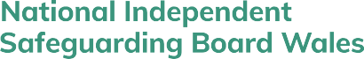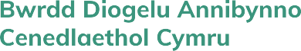Letter to Huw Irranca-Davies
Making recommendations to the Welsh Ministers as to how these arrangements could be improved
Minister for Children, Older People and Social Care

Welsh Government 5th Floor
Tŷ Hywel Cardiff Bay CF99 1NA

Dear Minister,

Recommendations to the Welsh Ministers as to how safeguarding arrangements could be improved
Since the term of office of the first National Board has passed so quickly we have decided to frame our reflections and recommendations by drawing on a distillation of our experience of working in Wales and elsewhere. What follows is our attempt to identify ways of working
which have promise in promoting more “safeguarding-conscious” services and exploring the full potentialities of the National Board in the future.

Notwithstanding the clarity of its statutory duties, the National Board has adjusted to the challenges and needs identified by the Regional Boards and negotiated a place for itself. Our work planning has sought to support and complement the work of the Regional Boards. Our comments on emergent guidance and Welsh Government commissions concerning safeguarding give expression to the National Board’s interest in adhering to the spirit and letter of the Social Services and Well-being (Wales) Act 2014.

The National Board has learned so much from bringing together key people in setting out the challenges of safeguarding in Wales and endorsing the significance of building networks with safeguarding leaders at all levels.

Making recommendations to the Welsh Ministers as to how these arrangements could be improved

Annual Report 2017-18 57

The acknowledgement of the Regional Board Chairs – the leaders and managers - of the need to work together, influence and inspire others is critical to preventing harm and protecting people.

Such fruitful initiatives have taken place alongside the National Board’s less visible negotiations in response to local pressures and events. In fact, learning has been a critical theme from the outset. The overused term “learning lessons” does not do justice to the learning associated with safeguarding which typically operates with ambiguous or incomplete information, the expertise that results from dealing with concrete problems and learning from accumulating experience. Experts typically draw on a range of solutions adapted to the problem. Expertise in adult safeguarding hinges on the use of legislation, a readiness to consider whether or not an individual is at risk of harm with “reasonable cause to suspect” that they may be so, making enquiries and taking thoughtful and proportionate action. This recalls one of the National Board’s missteps during 2016-17. We sought information from the Regional Boards about safeguarding training by invoking S.139 - which was ignored by four Boards! The timing was wrong but the intention behind it remains relevant. Although it is encouraging that Boards
are sharing their own analyses of training needs with Social Care Wales, there is no overview of safeguarding training in Wales and there are no standards against which training may be judged.

We recommend a national, e-learning safeguarding module for entry level/ tier 1 training which is relevant to sports clubs, the fire service and housing officers, for example, and which is not ring-fenced to social care
Another misstep of the National Board concerns our hesitancy in the use of social media. Having only dipped our toes in social media, it is arguably time to start paddling.

The National Board determined at the outset that it would not comment on individual Practice Reviews since this would compromise our duty to provide “support and advice” to the Regional Boards. This “rule of thumb” is recommended in spite of the full force of public opinion expressed in unmediated social media. However, there are three matters of relevance to Practice Reviews:

- their availability – although the regulation states, make the practice review report publicly available (The Safeguarding Boards (Functions and Procedures) (Wales) Regulations 2015 4. (5)(l)), some Regional Boards removed them from their websites. This led the National Board to accommodate reviews on its website during 2017-18
- the interpretation of the regulation, ensure that the practice review report does not reveal the identity or whereabouts of the child or adult who is the subject of the review or that of the subject’s family (4. (5)(i)). Gender is a critical consideration in safeguarding. Since people are not genderless and professionals do not deal with them as genderless, Practice Reviews should not make them so.
- Action planning - we would be misled if we thought that lengthy “Action Plans” addressed the harms and cruelties which result in Practice Reviews. Action Plans may take many months of chasing before they are finally “signed off” - by which time their connection to the rationale for the review may have been long since lost.

58 National Independent Safeguarding Board Wales

We recommend that all Child/ Adult Practice Reviews (a) are published on the National Board’s website on an interim basis and (b) that they specify the gender of the individuals concerned.
Disclosure and Barring Service (DBS) checks are exercising the Regional Safeguarding Boards. Questions which we have been asked include: should councillors be subject to DBS checking? Which agency should pay for the checking process? Why are different standards applied to professionals in contact with the same individuals? We have re-directed the questioners to the DBS and to Welsh Government in the knowledge that similar questions will continue to be asked.
Making recommendations to the Welsh Ministers as to how these arrangements could be improved

It appears to us that the desire to over-specify safeguarding activities remains very prominent and is played out in drafting of procedures and protocols – as though seemingly repetitive problems may be solved by prescribing an identical sequence of operations. It is disappointing that there is no brake on the development of protocols.

The regulations identify one of the functions of the Boards as:

3. (2) to cooperate with other safeguarding boards and the National Board with a view to-

- contributing to the development and review of national policies and procedures [emphasis added] for Safeguarding Boards,

- implementing national policies and procedures recommended by, and guidance and advice given by, the National Board.

The Statutory Guidance elaborates:

113. a) …and to contribute to developing policies and procedures to coordinate what is done by the partners and bodies represented on the Board for the purposes of protecting adults and children and preventing abuse…

123. A Safeguarding Board must ensure local protocols are in place which coordinate the inter-agency work being undertaken within the area of the Board and by Board partners and other bodies represented on the Board and by other bodies with safeguarding responsibilities. These protocols should be kept under review as to their usefulness and
effectiveness in informing and guiding individuals and agencies in their contact with the Board and their access to multi-agency protection services within their area, and to monitor how the

Making recommendations to the Welsh Ministers as to how these arrangements could be improved

Annual Report 2017-18 59

protocols improve inter-agency service responses and delivery in the area.

The questions the National Board posed last year remain pertinent because no specific protocols, tools, strategies or procedures are reported to have been abandoned as a result of reviews:18

- How are individuals who are known to have been at risk of harm involved in the development of protocols, tools, strategies and procedures?
- Do the Regional Boards have evidence that protocols, policies, tools and procedures are increasing the predictability of practice?
- How are practitioners assured that these documents are indispensable to informing
effective and efficient practice?
- Do the Regional Boards take the view that their protocols have applicability across diverse groups and situations?
- Are the Regional Boards assured that their protocols are helpful to the individuals receiving safeguarding services?
- How does the creation of non-statutory protocols ensure accountable implementation?
It appears that some Regional Boards are like software companies writing codes to protect their products. They are attuned to viruses which thrive on finding flaws and the response is to write evermore protective software. As new ‘problems’ come to light, policies are required to render the safeguarding system more comprehensive. Ways of removing the struts supporting this continuing generation of policies and their associated guidance is to amend paragraph 123 of the statutory guidance. There is a danger that practitioners will be overwhelmed by increasing volumes of national and regional protocols, policies and guidance.

We can confirm the obstinate persistence of all Regional Boards in their efforts to bring
the importance of safeguarding children, young people and adults to the attention of their communities. We do not want the energy behind such persistence to be dissipated or locked in the formula of protocols and guidance – because these cannot, and should not, direct the discretion of all professionals in all circumstances.

We recommend a more considered approach to the development of policies and procedures which addresses questions 1-6.
The 2017-18 Annual Reports from the six Safeguarding Board Areas evidence more compliance with the content requirements than last year’s reports. However, we do not share the faith of some organisations in their senior salaried managers attending meetings, giving or receiving presentations as evidence of collaboration. Board members’ attendance at Board and sub group meetings is an insufficient criterion of participation and collaboration.

18 Cwm Taf refers to “the cessation of existing protocols that are no longer relevant”

60 National Independent Safeguarding Board Wales

The experience of the National Board is that some agencies attend and contribute nothing. The Chairs may wish to consider complementing an agency’s self-assessment of its contributions with their own “audit” of the effectiveness of individual agency contributions to the multi-agency priorities.

There are some stunning examples of safeguarding children, young people and adults in Wales and yet the task of identifying the individuals, agencies and leaders responsible for these is not, so far, being undertaken. Some Boards have discarded the distortions that result from being wedded to a single way of doing things and are learning with children, young people and adults – as well as with colleagues across disciplines. The foundations of Mid and West Wales’ change initiatives result from senior managers acknowledging the resources and strengths of children and young people – and has changed the nature of relationships; and the lead Coroner in North Wales has endorsed the Regional Board’s work concerning adults who self-neglect – which is setting out where and how to begin the process of change grounded in the adults’ circumstances and priorities.
Making recommendations to the Welsh Ministers as to how these arrangements could be improved

We recommend that Regional Boards set out the ways in which they are (a) engaging with children, young people and adults and (b) taking action as a result.
The Regional Boards are more likely to engage with children and young people than with adults. The Violence Against Women, Domestic Abuse and Sexual Violence Act (2015) partnerships are connected to the work of the Regional Safeguarding Boards via overlapping membership. However, this does not imply a collaborative and integrated response from adult safeguarding and domestic abuse services. For example, acts of violence towards people of 60+ years are more likely to result in an inquiry under S.124 of the Social Services and Well-being (Wales) Act 2014 than the provision of assistance using a domestic abuse support framework, including access to civil and criminal justice options.19 The resulting under-recording of domestic abuse experienced by older people requires attention.

There are examples of learning from distressing events in the 2017-18 Annual Reports which were absent last year. For example, Cwm Taf reported its error in removing an elderly woman with dementia from her family home due to her “unexplained bruising” and that the decision to do so was premised on professionals’ flawed understanding of the law; North Wales described its investment in improvement work with Ysbyty Glan Clwyd/ Betsi Cadwaladr University Health Board, and specifically, its work with another failing Mental Health Unit at this hospital; and Mid and West Wales’ commitment to challenge stakeholders “to improve outcomes for people” arose from the shortfalls of Powys’ children’s services – exacerbated by “a high and rapid turnover” of senior staff plus a new Information Technology system which has prevented Powys from sharing data.

Generally, the annual reports contain too many acronyms, jargon and unexplained terms for general public readership. For example, “Bronze officers, MASE, CEF, SARC, Bedfordshire Action Plan, PRAMS service, PRMG, a high SERAF score and UNCRC.” Attention to proof reading and feedback from potential audiences should eliminate acronyms and jargon in all published material.
19 Wydall, S., Clarke, A., Williams, J. and Zerk, R. (2018) Domestic Abuse and Elder Abuse in Wales: A Tale of Two Initiatives British Journal of Social Work (48) 962-981

Making recommendations to the Welsh Ministers as to how these arrangements could be improved

Annual Report 2017-18 61

Highlighting the connection between the Board’s annual plans and outcomes for children, young people and adults is important even though it is not easy. The Regional Boards remain very focused on sorting out their structures, supports and terms of reference for example.
Steps are being made but it is up to the reader to guess what the destination/ long term scope is. There is merit in setting out the improvements made – as well as the setbacks – the outcomes for children, young people and adults, and the remaining tasks. For example, Mid and West Wales noted that “Further work will be undertaken in the coming year…to ensure [that] information captured is multi-agency as opposed to being overly reliant on social care information.”

We recommend that all Regional Boards report on how their plans and work programmes result in improved outcomes for individuals/ families; for the individuals alleged to be responsible for the harm; for the service; and for the commissioning bodies.
The National Board held back from recommending to Welsh Ministers that Health Boards credibly engage with Regional Safeguarding Boards prior to commissioning independent reviews which hinge on harm to patients, in favour of proposing a way of exploring a credible alignment with the purpose of Practice Reviews, that is, to identify any steps that can be taken by Safeguarding Board partners or any other bodies to achieve improvements in multi-agency child and adult protection practice (Regulations 4. (2)). We believe there is merit in leadership across health and social care in Wales undertaking a “Think twice if…” exercise to understand precisely the impacts of freestanding reviews on the individuals concerned, their relatives, practitioners across sectors and Regional Safeguarding Board areas.

From the National Board’s perspective, it is disappointing that the the gap in the regulations concerning the ownership of all documentation about safeguarding reviews has not been addressed. Eighteen months ago we recommended that Welsh Ministers deal with the confusion concerning the governance of the reviewing process. Permission to begin this work was received during September 2018. Also, we highlighted the paucity of provision for children who are known to children’s mental health and youth offending services as a matter requiring urgent Ministerial attention. Although it is now easier for these young people to be placed in secure services in England, we hope that Ministers will pay continuing attention to the circumstances that bring forth such placements – and to the human and legal costs of
Health Boards failing to identify the treatment services that young people require. We are not assured that the new rental market in specialist units, including “pop-up” support, for example, addresses the shameful practice of sending Welsh children and young people to other parts
of the UK. We speculate that the spike in applications to the High Court masks the failure to provide sufficient mental health treatment.

We recommend that the Welsh Government routinely advises the National Board of the applications it has made to the High Court asking it to exercise its ‘inherent jurisdiction.’
Introducing a National Independent Safeguarding Board into the complex worlds
of safeguarding children and adults was bound to require adjustment and mutual accommodation. It has been a means of introducing fresh thinking about the gains and challenges of safeguarding practice.

62 National Independent Safeguarding Board Wales

The National Board had a significant part to play in bringing the Regional Board Chairs together to share insights into their challenges and our relationships with the Chairs, the Regional Boards and the Welsh Government have matured and it is pleasing that
developments are taking place which bear the National Board’s fingerprints. However, only a partial view of the status of safeguarding in Wales is possible because there is no single data set that enables comparison. The Regional Boards are not required to set out referral data
in their annual reports – although Cardiff and Vale, Cwm Taf and Mid and West Wales do so. Cardiff and Vale and Cwm Taf report on the number and progress of Child/ Adult Practice Reviews; North Wales reports on the numbers of nursing and residential homes in “Escalating Concerns;” Cwm Taf and Western Bay reports the referrals arising from the Welsh Ambulance Service Trust; Gwent lists course titles, the number of sessions and attendees; and Cwm
Making recommendations to the Welsh Ministers as to how these arrangements could be improved
Taf reports the Deprivation of Liberty Safeguard assessments undertaken and those on its
“waiting list.”

We recommend that the Regional Boards, the National Board and the Welsh Government identify and agree five measures which reveal something of the adequacy and effectiveness of safeguarding arrangements
The work ahead includes attention to safeguarding “data;” Regional Boards’ assuming intrinsic responsibility for challenging each and all members to experience directly the consequences of their decision-making; prioritising a consistent training framework with specific standards; promoting the valuable and inspiring work of practitioners; making visible the invisible home educated children and young people; building on the excellent work of Amanda Robinson and colleagues in “pooling learning;” accessing the ideas and expertise of the Heads of Inspection Group which brings together the inspectorates with responsibility for children’s and adults’ services, most particularly concerning public value audits of multi- agency safeguarding boards; greater attention to the participation of children, young people and adults in shaping the Boards’ priorities – and paying particular attention to the voices
of those who are vulnerable to being excluded – the young people and adults with mental health problems, those with learning disabilities and those with sensory losses; and seeking Disclosure and Barring Service consistency across social care, health care and education in Wales. Regular Ministerial meetings would provide assurance that Regional Boards are making different dents in the obstacles to undertaking and tracking effective safeguarding practice.

It is tenacious practitioners across professions and sectors whose work is inspiring - even if their efforts do not always succeed. They make things right as often as they can and turn the instinctive care we have for each other into something which promises a hopeful future.

Finally, we have very much enjoyed working together – united in our determination to use the best of our ability and means at our disposal to harmonise our work programme with the interests of the Regional Boards. Although it is for others to judge our success, we believe that we have established the National Board as a valuable addition to Wales’ safeguarding landscape – and we wish our successor Board every success.

Margaret Flynn, Keith Towler, Simon Burch, Ruth Henke, Jan Pickles and Rachel Shaw

Making recommendations to the Welsh Ministers as to how these arrangements could be improved
Annual Report 2017-18
63

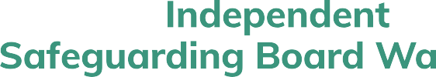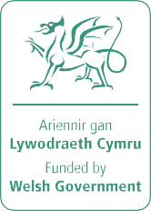

Keep in touch www.safeguardingboard.wales @NISBwales safeguardingwales

